Сrystal growth of scheelite-like double tungstates and molybdates

D.A.Lis, K.A. Subbotin, E.V. Zharikov
A.M. Prokhorov General Physics Institute of Russian Academy of Sciences (GPI)

In the scheelite (CaWO₄) structure (sp. gr. I41/a), Ca²⁺ locates in a somewhat distorted dodecahedral oxygen coordination, with two sets of bond distances: coordination number (CN) = 4 + 4. Each CaO₈ polyhedron share edges with four analogous dodecahedra. W locates in a slightly distorted tetrahedral coordination, with identical W–O bond distances (CN = 4), but different bond angles. In the NaR(TO₄)₂ (where R = Ln³⁺, Y³⁺, or Bi³⁺; and T = W⁶⁺ or Mo⁶⁺ scheelite-like double tungstates and molybdates phases, the Na⁺ and R³⁺ cations distribution on the dodecahedral (calcium) sites of the scheelite structure may be random (strictly statistical) or partially ordered. A strictly statistical distribution of the Na⁺ and R³⁺ ions does not change the symmetry of the crystal. A partially ordered cation distribution, as a rule, distorts symmetry of the crystal, and reduces it`s space group.
Na⁺ and R³⁺ cations, lie between the [TO₄] tetrahedra along the fourth-order crystallographic axis and are more or less randomly distributed over the crystallographic sites. Thus, the dopant R₁³⁺ ions substituting the host R³⁺ ions are affected by an infinitely large set of crystal fields with an infinitely small difference between each other. Therefore, the absorption and luminescence lines of R³⁺ ions in scheelite-like crystals demonstrate pronounced inhomogeneous broadening, which, along with the large number of Stark components of low-lying energy levels (for example, the ³H₆ level of Tm³⁺ ions has 13 Stark components) and comparatively small energy spacings between them gives rise to broad and rather smooth luminescence bands. This makes it possible to obtain easily continuous tuning of the wavelength of the laser oscillation [1] and to obtain subpicosecond laser pulses in the mode-locking regime. Furthermore, since the absorption bands are smooth and inhomogeneously broadened, possible temperature fluctuations of the emission wavelength of the pumping diode have not as drastic influence on the laser efficiency, as in case of ordered laser hosts like YAG. The advantages of the use of structurally disordered crystals as active media for solid-state lasers were considered more detail in [2].
The further disorder of scheelite structure may be accomplished by the simultaneous usage of different cations in R³⁺ and T⁶⁺ positions. One example of the first option was given in [3]. The crystals of mixed scheelite-like tungstates Tm³⁺: NaLa_{x}Gd_{1-x}(WO₄)₂ with a variable La-Gd composition occupy an intermediate position between the lanthanum and gadolinium tungstates. The efficient tuning of laser wavelength was demonstrated at this crystal [4].
Another advantage of scheelite-like crystals is very high probabilities of the electro-dipole transitions within f-electronic shell of Ln³⁺ laser dopants. It leads to high specific intensities of the optical absorption and luminescence bands of the doped crystals. Recently we found [5] that the main reason for such high probabilities is high distorsions of the local Ln³⁺ environment in the scheelite structure.
Over the last 10 years our team has made a large number of studies on the structure, spectral and lasing properties of crystals of double tungstates and molybdates [4,6-8]. A necessity to obtain the samples of high optical quality demanded to make a number of improvements in the standard Czochralski method.
The main problem in the growth of crystals of this type is their tendency to cracking predominantly in the <001> cleavage plane (perpendicularly to the optical axis) [9]. Cracking may happen during the growth process and upon the cooling of as-grown crystal to room temperature. This phenomenon is caused by large thermoelastic stresses, developing under the influence of the temperature gradient, and on the other hand, by relatively low mechanical durability of scheelite-like crystals. Besides that, significant anisotropy of thermal expansion coefficients is typical for scheelite-like crystals. In order to prevent such a cracking we used the growth directions parallel to the cleavage plane <001>, optimized the configuration of heat shields. In particular, significant increase of thermal gradients is related with the presence of a through hole in the radial direction, which served as a window. This inspection window makes a significant distortion in the shape of the temperature field, making it dramatically asymmetrical in the radial direction (see fig.1). We tested several variants of smoothing these distortions. Especially nice results gave the coverage of inspection window, made in ceramic heat-shields, by plate of transparent material (e.g. quartz). In this case, the inspection window is no longer straight-through, which sharply reduces the heat transfer through it and substantially smooth out the shape of the temperature field.
The insertion of a transparent cylindrical ring to the inside of ceramic heat-shields with a close location to the melt leads to quite rapid loss of transparency of the silica glass ring due to the condensation of the melt vapor on the surface of the window. Therefore, as a next step we start using a transparent ring, located in the outer layer of heat-shields. In this case, the inspection window maintains the acceptable transparency throughout the entire growth process, and the effect of lowering the thermal gradients does not reduce.
Modification of the heat-shields allowed us to avoid the problem of cracking of crystals on the stage of crystal growth. However, the crystals continued to crack at the stage of postgrowth cooling to room temperature. Therefore, we have made additional improvements to the configuration of heat shields, e.g. introduced the resistive annealing furnace instead of the inner heat shield. The furnace was controlled with a programmable thermocontroller. After tear off the crystal from the melt, it is raised to a level to be approximately in the middle of the temperature field resistive furnace. Then the RF-coil heating was reduced to zero during a short time (2-3 hours), and the furnace was programmed to reduce the temperature at ~10 degrees per hour. This improvement allowed on the one hand to substantially smoothen the temperature gradients above the crucible, and on the other hand, to reduce the cooling rate. As a result, the problem of cracking of crystals was practically resolved. Moreover, additional annealing of crystals in a muffle furnace is generally not required after the introduction of this improvement.
One can see from the fig.1 that the changes made in the design of heat-shields, have made nearly uniform axial temperature gradient (~9 K/mm) along the crystal growth axis and greatly reduce the asymmetry of the thermal field caused by a viewing window.
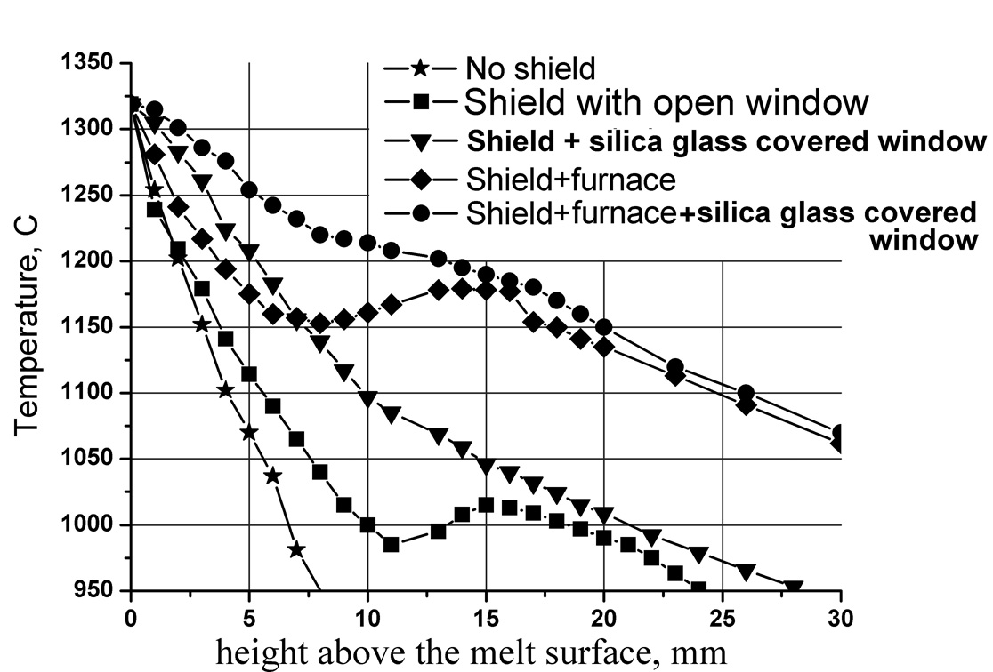
Fig.1. The temperature distribution above the melt surface
REFERENCES
- X. Mateos, V. Petrov, J. Liu, et al., IEEE J. Quantum Electron. 42, 1008 (2006).
- Yu.K.Voron’ko, K.A.Subbotin, V.E.Shukshin, D.A.Lis, S.N.Ushakov, A.V.Popov, E.V.Zharikov. Optical Materials, 2006, vol. 29, p. 246-252
- F.A. Bol'shchikov, E.V. Zharikov, N.G. Zakharov, D.A. Lis, P.A. Ryabochkina, K.A. Subbotin, O.L. Antipov. Quantum Electronics, 2010, Vol.40 (2) p. 101-102
- F.A. Bol'shchikov, E.V. Zharikov, D.A. Lis, N.G. Zakharov, P.A. Ryabochkina, K.A. Subbotin, O.L. Antipov, QUANTUM ELECTRON, 2010, 40 (10), 847–850.
- P.A. Ryabochkina, S.A. Antoshkina, S.A. Klimin, D.A. Lis, K.A. Subbotin, S.N. Ushakov, E.V. Zharikov. Journal of Luminescence, Volume 138, 2013, p.32–38
- F.Cornacchia, A.Toncelli, M.Tonelli, E.Favilla, K.A.Subbotin, V.A.Smirnov, D.A.Lis, E.V.Zharikov. J. Appl. Phys. 101, p. 123113 1-7, (2007)
- F.A. Bolschikov, G.M.Kuz’micheva, D.A.Lis, Yu.M.Papin, A.V.Popov, P.A.Ryabochkina, V.B.Rybakov, V.G.Senin, V.A.Smirnov, K.A.Subbotin, Yu.K.Voron’ko, V.V.Voronov, E.V.Zharikov. Journal of Crystal Growth v. 311 iss. 17 (2009) p. 4171–4178
- G.M. Kuzmicheva, V.B. Rybakov, K.A. Subbotin, E.V. Zharikov,
D.A. Lis, O.Zaharko, D.A. Nikolaev, V.G. Senin. Russian Journal of Inorganic Chemistry, Vol. 57, No. 8, 2012, p. 1128
- D. A. Lis, K. A. Soubbotin, E. V. Zharikov, et al., in Proceedings (Technical Digest) of 18th Topical Meetings on Advanced Solid State Photonics, San-Antonio, USA, 2003 (San-Antonio, 2003).

