Sustainable investing

Janusz Brzeszczyński
University of Lodz

Jerzy Gajdka
University of Lodz

Tomasz Schabek
University of Lodz

This version:
30th June 2009

ABSTRACT:

Sustainable investing as an investment strategy relies on the selection of stocks of the companies, which goods and services meet the criteria of ethical business practices and which avoid certain areas of business activity deemed as damaging environment or unethical. Such strategies are known also as socially responsible investments (SRI) or environmentally friendly investments. This paper reviews the literature on sustainable investing and SRI stocks as a class of financial instruments. We discuss the opportunities and present some implications for investors on the Polish capital market who can apply such selection criteria and use those stocks in their strategies. In particular, we analyze the risk and returns of companies, which in the Polish market meet the criteria of sustainable investing and discuss the obtained results relative to the changes of the broad market index.

Keywords: sustainable investing, socially responsible investments, beta estimation

- Introduction

Sustainable investments have become a rapidly growing field in finance and have been attracting an increasing attention of financial analysts and academic researchers (e.g. Schröder (2007), Kempf and Osthoff (2007), Bello (2005) and Scholtens (2005)). The available data show that in 2003 about 2,143 bn USD was allocated in socially screened portfolios in the USA, which constitutes as much as 11% of all assets under management (Social Investment Forum (2006)). Similar investments in Europe amounted to about 24 bn euro in 2005 with United Kingdom leading the market share with 8 bn euro worth of assets (Avanzi SRI Research Report (2005)).
In the literature the sustainable investments are known also under the names: socially responsible investments (SRI), ethical investments, socially conscious investments or environmentally friendly investments.
The main characteristic of this type of investment activity are the exclusion or inclusion criteria, which are applied in selection of stocks. The exclusion criteria may take form of the principles that the investor avoids stocks of the companies from particular industries, such as tobacco, alcohol, gambling, nuclear power, firearms or military. The inclusion criteria may take form of positive characteristics, such as environmentally friendly business activity, fair trade with developing countries, equal employment opportunities etc. Such selection rules are known in the literature and the investment community as “social screens”. Those screens may be both positive (when the inclusion criteria are used) and/or negative (when the exclusion criteria are applied). A broad discussion of SRI investments is presented in Kinder, Lyndenberg and Domini (1993) and Domini (2001).
Investment strategies built using certain exclusion or inclusion criteria lead to creation of portfolios, which have different characteristics than the otherwise created portfolios out of the wider universe of all available stocks.
The consensus in the literature is that, in theory, because of the adopted constraints and the resulting narrower group of possible stocks that can be bought, the sustainable investments funds should generate lower returns than other funds that have the same degree of risk (e.g. Schröder (2007)). Minor (2007) provides the discussion of following economic factors that explain this relationship. First, the nature of the forces of demand and supply implies that lower demand for a stock to which exclusion criteria may apply, but with similar financial results as an SRI stock, should lead to the divestment in this stock by some SRI funds, which in turn will increase its return relative to price. In consequence, the SRI funds that excluded this stock from their portfolios will experience worse performance in relation to other funds that did not neglect it as an investment asset. Second, the constraints adopted by SRI funds will limit their general investment opportunities and, hence, will restrict the diversification benefits and the funds’ expected return. Similar argument was presented and discussed earlier in Rudd (1981). Third, the SRI investor will suffer lower return due to the, so called, externalities (e.g. external costs of the company’s activity, such as pollution etc.), which will reduce its profit to the SRI investor but not to other investors. Therefore, the SRI investor will, again, suffer a relatively lower return by divesting this stock.
SRI investments have been gaining popularity among various groups of investors in the recent years, predominantly government-controlled funds, pension funds and private mutual funds specializing in the SRI stocks. Growing interest in the SRI assets has also led to creation of specialized stock market indices, such as, e.g., Domini 400 Social Index.
In this study we review the literature about the SRI investments and in the empirical part we use the data from the Polish capital market to analyze the SRI as a new investment opportunity in Poland.
The paper is organized as follows. Section 2 provides overview of available evidence on sustainable investments performance. Section 3 outlines the opportunities for the SRI investors in the Polish stock market by presenting the beta estimates of SRI stocks as well as returns of the simulated portfolios composed of companies meeting the sustainable investments criteria. Section 4 discusses the main findings and concludes.

- Evidence on sustainable investments performance

The SRI investments in environmentally friendly stocks using certain exclusion or inclusion criteria have been investigated in various markets in recent years, however the existing evidence is very limited and fragmented. Moreover, the available findings about the investment results of SRI funds are rather mixed.
The evidence about the performance of SRI investments can be generally classified into the three broader groups of analyses: (i) individual stocks selected using the inclusion or exclusion screens (e.g. Kempf and Osthoff (2007)), (ii) mutual funds or investment funds specializing in SRI (e.g. Bello (2005), Scholtens (2005)) and (iii) SRI stock market indices (e.g. Schröder (2007)).
Kempf and Osthoff (2007) simulated a trading strategy for individual stocks based on socially responsible ratings provided by the consultancy company KLD Research & Analytics. According to the implemented rules, an investor would buy stocks with high rating (open long positions) and sell stocks with low rating (open short positions). The results for the US data analysed in the period from 1991 until 2003 indicated that this strategy has led to high abnormal returns of up to 8.7% per year with the best performance achieved when the best-in-class screening approach was applied, a combination of several socially responsible screens simultaneously was used and the selection was limited to stocks with extreme ratings values. In the study of Kempf and Osthoff (2007) the abnormal returns remained significant even after the transaction costs were taken into account.
Schröder (2007) analysed 29 international stock indices that represent socially responsible investments and compared them to conventional benchmark indices. The investigated SRI indices covered companies from USA, Canada, UK, Australia, Sweden as well as a broader composition of European and World stocks. The results based on the sample of data spanning the period from 1994 to 2003 demonstrate that these indices do not exhibit a different level of risk-adjusted return than conventional benchmarks.
Similar conclusions were reached by Bello (2005), who investigated a group of socially responsible stock mutual funds and found that the investment results of those funds do not differ significantly from conventional funds in terms of any of the analyzed criteria, such as: portfolio diversification and variable effects of diversification on investment performance. The earlier studies of Hamilton, Jo and Statman (1993) and Statman (2000) also for mutual funds evidence negative excess return of SRI funds (yet the difference is not statistically significant) or find that the their performance is not significantly different from that of conventional funds of similar value of net assets.
Scholtens (2005) provides results about the performance of Dutch socially responsible investment funds in years 2001-2003 and concludes that they outperform conventional funds, but the difference is not significant.
It is worthwhile to mention here that there exist evidence about performance of the opposite investment strategies, which rely on the selection criteria that favor stocks from tobacco, alcohol, military or gambling industries. Such investments are usually made by specialized funds, known commonly as “vice funds”. The results by Shank, Manullang and Hill (2005) show that the differences in performance between the SRI and vice funds are negligible. However Lobe and Roithmeier (2008) demonstrate that publicly traded companies that are involved in the industries, typically excluded by negative screens in SRI funds, can generate abnormal returns.
As discussed above, the available research on SRI investments is rather limited and the findings about the performance of such funds are not unequivocal. If, however, the SRI investments lead to higher returns, then one of the possible explanations, as discussed in Minor (2007), could be that SRI fund managers are more skilled than conventional fund managers. Additionally, the investment opportunities available to the SRI fund managers are by nature restricted compared to other fund managers, which means that they cover smaller group of companies and can possibly identify those profitable investments which may be overlooked by other funds, which invest in a much broader universe of stocks (Minor (2007)). This conclusion, paradoxically, applies to both SRI investments as well to their opposite trading strategies based on selection of stocks that compose the vice funds.

- Sustainable investments in the stock market in Poland

In this section we present description of data and provide results of two types of analyses for risk and return of stocks that can be classified as SRI investments: estimation of beta coefficient for the stocks meeting the SRI criteria and the results of investment in a portfolio composed of those stocks.

  - Data

In the first step, we made a selection of stocks from the Polish capital market based on the description of their business activity. The source of information about all companies was the Notoria database. We applied exclusion and inclusion criteria meeting the commonly accepted standards of sustainable investing.
Since the SRI are a new type of investment activity in Poland, there are no mutual or investment funds or stock market indices yet that would precisely define which stocks are considered to belong to such category of assets. Hence, we had to make our own selection based on the information provided by the companies and collected by Notoria.
It is worth mentioning that no company explicitly declared itself to be a clearly SRI stock. In this case, we analyzed all descriptions for all firms listed on the Polish stock market and identified those, which in their business deal with such activities as: environment protection, environmentally friendly investments, toxic and environmentally dangerous waste disposal, sewage cleaning and recycling and green areas landscaping.
Out of all companies listed on the Warsaw Stock Exchange (WSE) main market and the New Connect market only 12 stocks met these criteria (8 from WSE and 4 from New Connect).
The sample in our analysis was restricted by the length of time when the selected stocks have been listed on the stock exchange and it covers the period from 31.03.2008 to 18.05.2009. Some stocks, however, have shorter time series, which are equal to period of their listing on the WSE.

3.2. Estimation of beta coefficients

In this section, we present characteristics of SRI stocks from the point of view of their risk and sensitivity to the market movements. In particular, we provide evidence about the estimates of beta coefficients (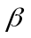) for the selected stocks.
There is a rich literature about various problems relating to the estimation of beta as the most commonly used measure of risk. In this paper we focus only on two most important aspects: the choice of interval used for the construction of stock returns (known also as the “intervalling effect”) and the estimation method (most notably: heteroscedasticity and ARCH effects).
We estimated beta coefficients for all 12 selected SRI stocks for 3 different intervals: daily, weekly and monthly.
Whenever heteroscedasticity was present (which we checked using the ARCH Lagrange multiplier test) we applied ARCH methodology and beta was estimated using the GARCH(1,1) model. If there was any remaining heteroscedasticity detected, we estimated a higher order GARCH. In every case we tested for autocorrelation using the Q-statistic and, if it existed, we eliminated it by imposing a relevant structure of AR and/or MA terms.
Beta estimates were obtained from the following ARCH type model (cf. Engle (1982)):

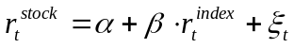, (1)
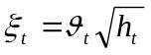, (2)
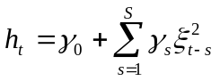 (3)

where and are model’s structural parameters and 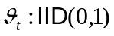, 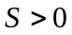, 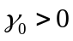 and 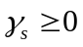. Additionally, it is assumed that 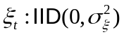, the error term is not autocorrelated and there is no covariance between the error term and the explanatory variable. The variables 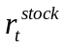 and 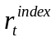 are the returns of the stock and market index, respectively. The order and type of ARCH model is determined by the specification of conditional variance function, h_{t}, in (3). The most popular and most frequently used modification is GARCH(S,Q) of Bollerslev (1986) with the following form of h_{t}:

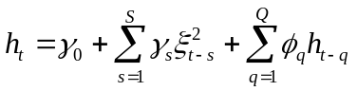 (4)

where , 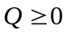, , and 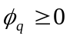.
In case of no heteroscedasticity and no ARCH effects, the parameter was estimated from only equation (1) using simple ordinary least squares (OLS) method.
The estimations of betas for all three intervals were performed using the longest data sample available for every stock, which means that the length of time series for some stocks is not necessarily equal due to the differences in the periods during which they were listed on the Warsaw Stock Exchange.
Table 1 presents estimated betas for daily, weekly and monthly intervals for all 10 stocks out of the 12 stocks initially available in the database. The results for two stocks could not be used for comparisons because no valid estimates were obtained due to the short length of their time series and the resulting problems with convergence of the numerical procedures. Table 1 contains also only those results, which were statistically significant. For one stock (ORGANIC) there was no significance for any of the investigated intervals and for four other stocks (ATONHT, DROP, INTROL and KREC) the results were not significant in case of either one or two intervals.

Table 1. Estimates of beta for daily, weekly and monthly intervals.

Stock: | daily |  | weekly |  | monthly
ATONHT | 0,81 | ARCH | 1,11 | OLS | - | -
BAKALLAND | 0,28 | ARCH | 0,28 | OLS | 0,59 | OLS
BOS | 0,37 | ARCH | 0,36 | ARCH | 0,32 | OLS
DROP | - | - | 0,37 | OLS | - | -
HBPOLSKA | 0,69 | OLS | 0,67 | OLS | 0,75 | OLS
IMPEL | 0,46 | ARCH | 0,60 | OLS | 1,04 | OLS
INSTALKRK | 0,51 | ARCH | 0,61 | ARCH | 1,05 | OLS
INTROL | 0,19 | ARCH | 0,29 | OLS | - | -
KREC | 0,70 | OLS | 0,50 | OLS | - | -
ORGANIC | - | - | - | - | - | -
Number of ARCH models: | 6 |  | 2 |  | 0
Number of OLS models: | 2 |  | 7 |  | 5

The results in Table 1 demonstrate two important following findings.
First, the number of ARCH effects increases as the interval is lengthened. For the daily intervals heteroscedasticity was present in the majority of the analyzed models and 6 estimates were obtained from the ARCH type models while only 2 from the models with OLS. For weekly intervals the situation was reversed and for monthly intervals all estimates were obtained using the OLS.
Second, the beta estimate increases for longer intervals. The lowest betas for every stock are associated with the daily and the highest ones with the monthly intervals. Such result may be explained by relatively low market capitalization and low liquidity of stocks selected as the SRI companies for this investigation. Among them only two companies (BOS and HBPOLSKA) should not be treated as small capitalization stocks. This result confirms the findings from other markets reported in the literature (cf. Cohen et al. (1980) or Handa et al. (1989) among others).
It is also worthwhile to note that most of the obtained estimates are below 1, even for the longest monthly intervals, which indicates that the analyzed SRI companies exhibit low sensitivity to the movement of the market index.

Table 2. Capitalization of SRI stocks (in mln PLN) on 31.03.2008.

Stock: | mln PLN | Stock: | mln PLN
ATONHT | 15 | IMPEL | 224
BAKALLAND | 123 | INSTALKRK | 155
BOS | 1202 | INTROL | 213
DROP | 118 | KREC | 25
HBPOLSKA | 1256 | ORGANIC | 53

3.3. Investment results in portfolio of SRI stocks

In this section we attempted to answer the question about the profitability of investment in the SRI stocks in the Polish capital market using the available data.
In order to do that, we created two portfolios of stocks selected and described above, one equally weighted and one capitalization weighted, and calculated their returns over the period of 31.03.2008 – 18.05.2009.

Figure 1. SRI stocks portfolio (equally weighted) and the stock market indices: WIG and sWIG80.
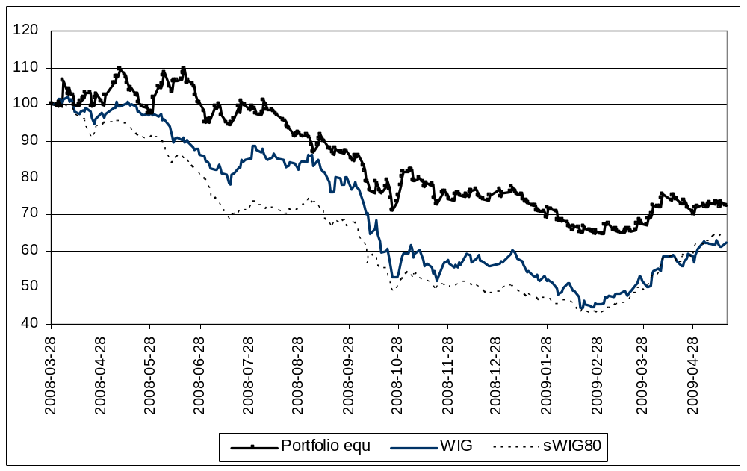
Figure 2. SRI stocks portfolio (capitalization weighted) and the stock market indices: WIG and sWIG80.
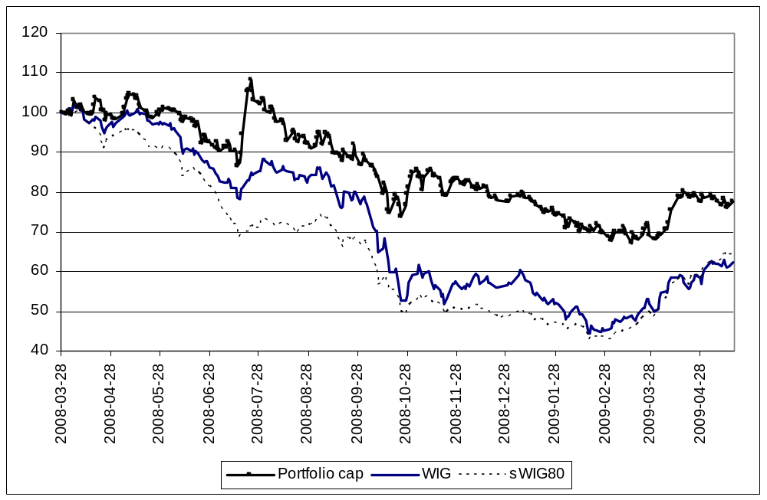
Figures 1 and 2 depict the performance of the SRI portfolios and the stock market indices (standardized to the value of 100 at the beginning of the investigated period). They clearly show that both portfolios have beaten the WIG and sWIG80 indices. The analyzed period was characterized, however, by the constantly decreasing value of prices and the stock market was in a “bear market” phase. Hence, the portfolios of SRI stocks suffered a loss, but it was much smaller than the negative change of value of the benchmark market indices. The results also demonstrate that portfolios composed of SRI stocks were capable of beating the market after accounting for risk In table 3 we present the values of one of the most important measures of volatility-adjusted performance, i.e the Sharpe ratio, in the form modified for negative returns (Israelsen 2005).

Table 3. Modified Sharpe ratio

 | SRI stocks (portfolio  with equal weights) | WIG | sWIG80
Average return | -0,0010 | -0,0015 | -0,0015
Standard deviation | 0,0167 | 0,0205 | 0,0141
Modified Sharpe Ratio | -0,000019 | -0,000033 | -0,000023

Note:
The modified Sharpe ratio (S) was calculated based on the formula presented in Israelsen (2005) :
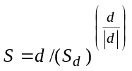 ,
where d is the mean daily difference between the portfolio return (daily) and the risk-free return(daily), 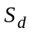is the sample standard deviation of daily differences between the portfolio return and the risk-free return.
The risk-free rate for the Polish market is the return of the 52-week Polish government Treasury bill. Its daily value for each month was obtained using the following formula: 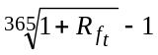 (where 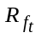 is the risk-free annual return obtained for every month). The source of the risk-free rate data is Polish Ministry of Finance.

The highest value of modified Sharpe ratio of SRI portfolio confirms its superiority in the analyzed period.

The capitalization weighted portfolio was re-shuffled every 6 months by taking into account new weights (end of September 2008 and end of March 2009). It is worthwhile to note also, that it was dominated by just 2 stocks, which constituted about 70% of the portfolio’s value, hence it is not well diversified. This is, however, a general problem more widely discussed in the literature that the SRI portfolios are usually poorly diversified due to the nature of the underlying selection process (e.g. Renneboog, Horst, Zhang (2007) and Bello (2005)). Additionally, the small stock bias may explain relatively better returns comparing to other, broad market, indices. However in our sample, the SRI portfolio has beaten also the sWIG80 index of small stocks.

- Conclusions

Investments in stocks using SRI exclusion or inclusion criteria are a new type of activity in the financial market in Poland. Hence, the related research analyses and the available evidence about performance of such strategies in the Polish capital market are very limited. To the best of our knowledge, this is the first such study, which uses the data from the Warsaw Stock Exchange and attempts to identify the SRI stocks, assess their risk and calculate their returns relative to the movement of the broad market indices.
Our findings show that the risk of the SRI stocks in Poland, as measured by the beta coefficient, is relatively low comparing with the market. On the other hand, the performance of the strategy relying on the selection of SRI companies is surprisingly good and the simulated portfolios did beat the market in the whole period under investigation.
The main limitations of this study are, by nature, related to a small group of stocks that meet the SRI investing criteria and a period of time for which the data was available. It allowed only for the analysis using a relatively short time series of historical data, which means that the formulated conclusions need to be treated with great caution.
Nevertheless, our findings shed some light on the possibility of construction of more complex trading strategies involving the SRI stocks and open up space for further research that should lead to more conclusive results based on more data and longer time series.
Another important implication of this new research stream could be the creation of the SRI index for stocks listed on the Warsaw Stock Exchange. It should attract more interest of the investors, who are active on the Polish market, and could lead to allocating more capital in this type of assets. On the other hand, the awareness of some companies listed on the WSE about the SRI identity should be increasing over time and some of them may decide to begin declaring themselves as SRI stocks, hence stronger defining their SRI attitude.
Finally, it is worthwhile to emphasize two important econometric results that we present in this study: the existence of the intervalling effect in the estimation of beta coefficient among the selected SRI stocks and the dominance of heteroscedasticity in the models using short returns intervals, which implies the necessity of applying ARCH models for correct estimation of betas.

References:

Avanzi SRI Research Report (2005), “Green, Social and Ethical Funds in Europe” (available at: http://www.avanzi-sri.org/pdf/complete_report_2005_final.pdf).

Bello Z. (2005), “Socially Responsible Investing and Portfolio Diversification”, Journal of Financial Research, Vol. 28, pp. 41-57.

Bollerslev T. (1986), “Generalized Autoregressive Conditional Heteroscedasticity”, Journal of Econometrics, Vol. 31, pp. 307-327.

Brailsford T. and Josef T. (1997), “The Impact of the Return Interval on the Estimation of Systematic Risk”, Pacific-Basin Finance Journal, Vol. 5, pp. 357-376.

Cohen K., Hawawini G., Mayer S., Schwartz R. and Whitcomb D. (1980), “Implications of Microstructure Theory for Empirical Research on Stock Price Behaviour”, Journal of Finance, Vol. 35, pp. 249-257.

Derwall J., Gunster N., Bauer R. and Koedijk K. (2004), “Socially Responsible Investing The Eco-Efficiency Premium Puzzle”, EFMA 2004 Basel Meetings Paper, Erasmus University Working Paper.

Domini A.L. (2001), “Socially Responsible Investing: Making a Difference and Making Money”, Dearborn Trade, Chicago.

Engle R.F. (1982), “Autoregressive Conditional Heteroscedasticity with Estimates of the Variance of United Kingdom Inflation”, Econometrica, Vol. 50, pp. 987-1008.

Frankfurter G., Leung W. and Brockman P. (1994), “Compounding Period Length and the Market Model”, Journal of Economics and Business, Vol. 46, pp. 179-193.

Goldreyer E. and Diltz J. (1999), “The Performance of Socially Responsible Mutual Funds: Incorporating Sociopolitical Information in Portfolio Selection”, Managerial Finance, Vol. 25, pp. 23-36.

Hamilton, S., Jo H. and Statman M. (1993), “Doing Well While Doing Good? The Investment Performance of Socially Responsible Mutual Funds”, Financial Analysts Journal, Vol. 49, pp. 62–66.

Handa P., Kothari S. and Wasley C. (1989), “The Relation Between the Return Interval and Betas: Implications for the Size Effect”, Journal of Financial Economics, Vol. 23, pp. 79-100.

Handa P., Kothari S. and Wasley C. (1993), “Sensitivity of Multivariate Tests of the Capital Asset Pricing Model to the Return Interval Measurement”, Journal of Finance, Vol. 48, pp. 1543-1551.

Hawawini G. (1983), “Why Beta Shifts as a Return Interval Changes”, Financial Analysts Journal, Vol. 39, pp. 73-77.

Israelsen C. (2005), “A Refinement of the Sharpe Ratio and Information Ratio”, Journal of Asset Management, Vol. 5-6, pp.423-427.

Kempf A. and Osthoff P. (2007), “The Effect of Socially Responsible Investing on Portfolio Performance”, European Financial Management, Vol. 13, pp. 908-922.

Kinder P., Lyndenberg S.D. and Domini A.L. (1993), “Investing for Good”, Harper Collins, New York.

Lewis K. (1991), “Should the Holding Period Matter for the Intertemporal Consumption-based CAPM?”, Journal of Monetary Economics, Vol. 28, pp. 365-389.

Lobe S. and Roithmeier S. (2008), “Vice vs. Virtue Investing” (available at: http://ssrn.com/abstract=1089827).

Minor D. (2007), “Finding the [Financial] Cost of Socially Responsible Investing”, Journal of Investing, Vol. 16, pp. 54-70.

Renneboog L., Horst J. and Zhang C. (2007), “Socially Responsible Investments Methodology, Risk Exposure and Performance”, ECGI Working Paper Series in Finance.

Roll R. (1981), “A Possible Explanation of the Small Firm Effect”, Journal of Finance, Vol. 36, pp. 879-888.

Rudd A. (1981), “Social Responsibility and Portfolio Performance”, California Management Review, Vol. 23, pp. 55–61.

Scholtens B. (2005), “Style and Performance of Dutch Socially Responsible Investment Funds”, Journal of Investing, Vol. 14, pp. 63-72.

Schröder M. (2007), “Is there a Difference? The Performance Characteristics of SRI Equity Indices”, Journal of Business Finance and Accounting, Vol. 34, pp. 331-348.

Shank T.M., Manullang D.K. and Hill R.P. (2005), “Is it Better to be Naughty or Nice”, Journal of Investing, Fall 2005, pp. 82-87.

Social Investment Forum (SIF Industry Research Program) (2006), “2005 Report on Socially Responsible Investing Trends in the United States” (available at: http://www.socialinvest.org/).

Statman M. (2000), “Socially Responsible Mutual Funds”, Financial Analysts Journal, Vol. 56, pp. 30–39.

Turtle H. (1994), “Temporal Dependence in Asset Pricing Models”, Economics Letters, Vol. 45, pp. 361-366.

First origins of SRI are associated with the Religious Society of Friends (Quakers) in the USA in the XVIII century. Other related historical movement is represented by John Wesley (1703-1791), who was one of the founders of Methodism. His sermons "The Use of Money" presented some basic tenets of social investing. Many applications of socially responsible investing were, in fact, religiously motivated; i.e. investors would avoid “sinful” companies associated with such products as guns, liquor or tobacco (www.wikipedia.com).
Existing evidence from various markets shows that the estimate of beta is sensitive to the choice of returns’ interval. For example, Cohen et al. (1980) demonstrate that the betas depend on the interval length and in case of stocks characterized by low liquidity the beta increases, while in case of stocks characterized by high liquidity it decreases, as the interval is lengthened. Handa et al. (1989) found that as the interval is extended the betas of portfolios composed of stocks with low capitalization increase while the betas of portfolios composed of stocks with high capitalization decrease. Roll (1981) argues that low capitalization stocks are usually characterized by relatively low frequency of transactions and, hence, the level of risk assessed based on short periods may be „underestimated” comparing with the “correct” risk. Also Handa et al. (1989) show that for low capitalization stocks the betas tend to increase as the interval is lengthened. Frankfurter et al. (1994) report that as the interval is extended the difference between the highest and the lowest value of betas decreases. Other related studies on the intervalling effect in beta estimation include: Handa et al. (1993), Lewis (1991), Turtle (1994), Hawawini (1983) and Brailsford and Josef (1997)).
When heteroscedasticity is present and the OLS method is used, the estimators of models’ parameters are unbiased but not efficient, which leads to serious estimation errors (not only in magnitude but also often in sign). In practice, in such instances the will be either overestimated or underestimated; hence its value will be wrong. In ARCH type models the correct estimates are obtained by using the information about the variance of the error term, contained in the h_{t} function, and correcting the estimates that are flawed when OLS is applied.

