Auto Healing of Early Aged Cracking of High Strength Concrete,
damaged by Cyclic Freeze-Thaw

Andrzej S. Nowak* and Taejun Cho**
*Professor of the Dept. of Civil Eng., University of Nebraska, W181 Nebraska Hall, Lincoln, NE, USA
** Professor of Dept. of Civil Engineering, Daejin University, Gyeonggi-Do 487-711, Korea

ABSTRACT
This paper presents an innovative solution for the auto healing concrete structures damaged by cyclic freeze-thaw. The additional hydration of high strength concrete, cured in high temperature, applied as auto curing for the damaged concrete micro-pore structures. Modeling of micro pore structure is prior to damage analysis. The micro-pore structure is composed as gel-pore and capillary pores, which grows with hydration. The amount of ice volume with temperature dependent surface tensions, freezing pressure and resulting deformations, and cycle and temperature dependent pore volume has been calculated and compared with available test results. The damaged and hydrated micro pore structures are modeled numerically. Heating the selected area of specimen in frozen chamber, the experimental results show approximately 100%of strength recovery after two weeks of freeze-thaw tests, fluctuating from 4° to -6° Celsius.
Keywords: Cyclic Freeze-thaw, Auto healing, pore structure, high strength concrete, numerical analysis

1. INTRODUCTION

Background:

Significance:

Compose: The proposed method includes three theoretical numerical models as follows:
1. Modeling of micro pore structure is prior to damage analysis. Considering material, structural, and environmental variables, the micro pore structures has been modeled. [Maekawa et al. 1982-2005]
2. Accumulated cyclic damage model for freeze-thaw of concrete structures had been studied [Cho et al., 2003-2005].
3. Auto healing of concrete structures, in higher ambient temperature, has been modeled [Nakarai et al., 2004] and verified in the experiments of this study.

Three techniques are combined for this study as like the following:
1. Numerical modeling for the hydration of concrete micro structure
2. Numerical modeling of the damage in concrete due to cyclic freeze- thaw
3. Auto healing of young aged concrete from micro cracking

2. Modeling of Micro pore structure of concrete

Hydration and micro structural information are obtained from the analysis results of DuCOM (Maekawa et al. 1995), which calculates the early aged strength, heat of hydration, micro-pore volume, shrinkage, corrosion of embedded steel and transportation of free water in concrete (Zhu 2004).
In DuCOM, for the hydration model, multi-component chemical reactions and compounds have been considered as input data. Based on solidification theory, the reactants, mainly cement, aggregate and water, produce C-S-H gel structures, as modeled schematically in a cluster at Fig.1.
Fig.1 shows the solidification process of cement paste is idealized by the formation of finite age-independent structural elements called clusters. The aging process of cement paste is represented by the solidification of new cluster. As hydration proceeds, number of clusters increases (Fig.2).
The surface areas of capillary and gel pores can be computed using a bi-model R-R porosity distribution f(r) which gives the total porosity function. Thus, we have,
where r: pore radius. V_{g}(r) and V_{c}(r) represent the fractional pore volumes of gel and capillary pores in the distribution, respectively (Fig.3).
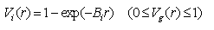
In the Fig.3, the distribution parameters B_{i} represent the peak of the porosity distribution on a logarithmic scale. If we assume a cylindrical pore shape in such a distribution, these parameters can be easily obtained from the computed porosity and surface area values for the capillary and micro-gel regions.

3. Numerical model for the damage by cyclic freeze-thaw
3.1 Driving Force of Freezing
The molar Gibbs free energy (chemical potential) of ice and water are like the following:
For bulk water:
For brine water (wolfe 2001):
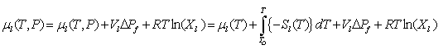
The main assumptions used for the derivation of driving forces are as follows:
1. In highly saturated pores, ice expansion pressure brings higher stresses in frozen concrete. Thus, material follows nonlinear-fracture constitutive law.
2. Fully saturated gel pore begets much bigger ice expansion pressure than partially saturated case.
3. By the ice expansion pressure, pore volumes are increased. Thus, the saturation of ice and pressure are decreased.
4. Strain by thawing is obtained by the different thermal expansions of water, ice, cement paste, and aggregates.
For the potential of ice:
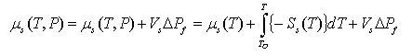)
By equating the two potential statuses, the pressure in bulk water can be obtained
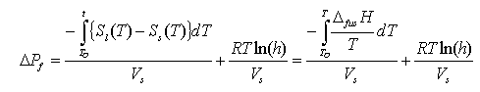
And the pressure in brine water can be obtained:
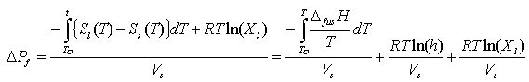
where the heat of fusion is approximately assumed as follows:
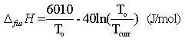

3.2 Micro cracking model
To predict the length of micro-cracking by frost actions as an evaluation of micro cracking, based on fracture mechanics, the stress intensity factor has been considered (Mihashi 1997):
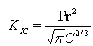
where K_{IC} is the mode I stress intensity factor of the porous material. When pore has enough internal freezing induced pressure P, the pore will show crack length of 2C in Mode I.
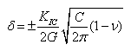
The increased crack length is obtained by double the crack half length C (Eq.39), with the G (the modulus of rigidity), C, and K_{IC}, considering symmetric condition; we can obtain the total displacements.
Considering the distribution of micro pores, the increased pore volume can be calculated by various ways: One of the methods can be direct integration using the distribution density function as the following:
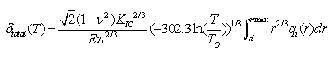
In the considered equation above, as expressed as unequal signature, there might be a problem of dimension, while integrating. Therefore, the authors propose another numerical method: The individual crack propagation and volume increase in micro-pores are obtained by the integration of Eq.40, by the use of distribution function shown in the Fig.9.
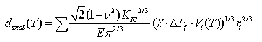
Where V_{i}(T): volume of ice at temperature T
Increased Pore Volume (Volume_cone)=(2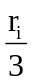)(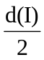+r_{i})²
Initial Pore Volume (Volume_sphere)=(4•3.11592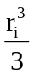)
N=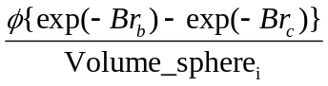: Number of air pores in a divided section (Fig.9)
Using fracture mechanics, the macroscopic deformation can be evaluated like the following:
Using fracture mechanics, the macroscopic deformation can be evaluated like the following:
r_{i}: the minimum freezable radius was used
r_{max}: 0.0001 meter is assumed
K_{IC}: obtained from the regression analysis (Fig.9)
Finally the total increased pore volume is:
Volume =(Volume_cone- Volume_sphere)
Finally, the increased Volume=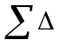Volume
In Fig.5, where the Stress Intensity Factor is calculated from the regression analysis of the experiments *(Kim and et al.,.1997).
For OPC,
K_{IC}=0.955284*{exp(4.2e-5T)-exp(-0.298908T)}*(5.144-4.995*w/c)
For silica fumed,
K_{IC}=0.955284*{exp(4.2e-5T)-exp(-0.298908T)}*( 4.839-4.844*w/c)
Where T is days, and 0< w/c: (%/100) <1.

3.3 Increased pore volume
Due to the different ice expansion pressure depending on the saturation, the pores need to be considered respectively. Dividing capillary and gel pores, the increase of pore volumes and saturation have been evaluated separately and updated as follows:
1. Pore volume of capillary pores:
2. Equivalent radius of capillary pores: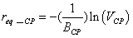
3. Increased pore volume of capillary pores (Section 5.2.1):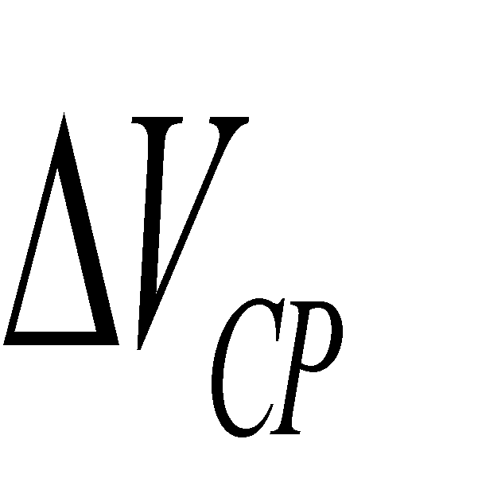 4. The normalized increased pore volume of capillary pores:
5. The updated B factor: 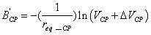
6. Pore volume of capillary pores:
7. Equivalent radius of capillary pores: 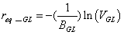
8. Increased pore volume of capillary pores: 
9. The normalized increased pore volume of capillary pores
10. The updated B factor:
where the increased pore volumes should have to be updated after each free-thaw cycles (Fig. 5).

3.4 Structural deformation
The total freezing deformation can be given by the sum of each deformation, sum of thermal expansion,
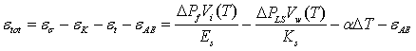
where the considered strains are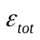: total strain, 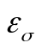: expansion strain (Mihashi, 2004), 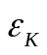: contraction strain by micro-ice-lens theory (Setzer, 2001), 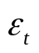: thermal contraction strain considering 4 materials, which are ice, water, cement and aggregates, and the volume of unfrozen water, V_{w}(T), will be the difference of V_{tot}-V_{i.}
The volume of ice is:
The fractional pore volume of the distribution (cc/g) is:
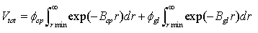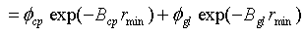
where 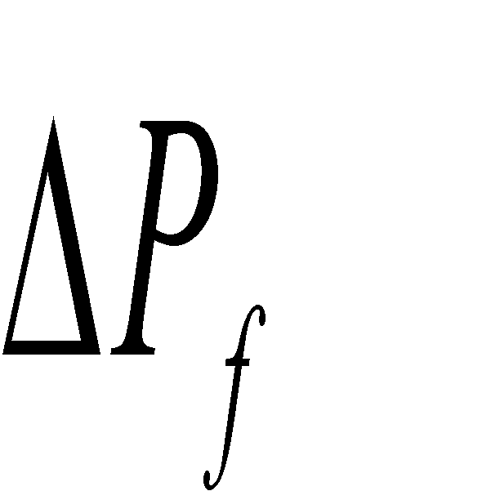 is obtained from Eq.33 and Eq.34, and (Micro-ice-lens model, Setzer 2001) , : temperature in Celsius, respectively.
The reduced strain by the effect of entrapped and entrained air pores,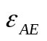, the volume of ice (m³/m³) depends on the distribution of gel pore and capillary pores in each section from the distribution: The distribution of entrapped and entrained air pores were modeled as:
If the air pores are 2%,

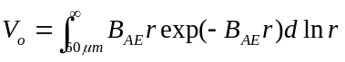=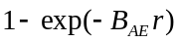=0.02 (=2%) (59)
where the diameter of entrapped air pores: 2000-5000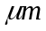, the diameter of entrained air pores: 60-1000 , distribution factor of entraiend air:B_{AE}(2%)=2000, and B_{AE}(7%)=7257.07 when the average of the radius of entraiend air pores is r_{avg}=138.

4. Auto healing for the damage by cyclic freeze-thaw
(2)十分に養生を行った後に生じる温度履歴の影響
ここでは，常温環境下で十分な封緘養生を行った試験体に対して，図-38に示すように環境温度を増加させて，それによる水和の影響を検討する．修正解析Aでは，形成される空隙構造の粗大化のみによって高温環境下での水和の促進を説明しているため，常温環境下で十分な養生を行い，水和物析出空間である毛細管空隙が水和物で占められ，緻密なゲル空隙が形成された後では，環境温度が高温になった場合でも，水和析出空間が枯渇しているため，その後の水和にはほとんど影響を与えない(図-39,40)．一方，修正解析Bでは，環境温度の違いによる水和物析出可能空間の変化によって高温環境下での水和の促進を説明しているため，常温環境下で十分な養生を行い緻密なゲル空隙のみになった後であっても，環境温度が高温になった場合には，ゲル空隙内の水和物析出可能空間が増加し，大きく水和が進行することになる(図-39,40)．修正解析Cは，A及びBを統合したものであり，今回の解析では，修正解析Bと同様の結果が得られる(図-39,40)．
Table 4. Mix proportion and Minerals
No. | W/C | 単位量（kg/m³） |  |  |  | 鉱物組成
No. | W/C | W | C | S | G | C₃S | C₂S | C₃A | C_{４}AF
P25 | 25 | 440 | 1762 | 0 | 0 | 54.37 | 19.86 | 9.42 | 8.79
25N | 25 | 441 | 1765 | 0 | 0 | 60.55 | 14.23 | 8.22 | 8.86
This prediction will be verified using the results of DuCOM: the degree of hydration as a hydration rate, micro pore structures, and the amount of hydrated water.
Considering the effect of additional hydration (Fig.7, P25b: recovered difference of 20%), the specimens which are heated will show similar compressive strengths and Elasticity compared with the specimens, cured in room temperature.

(2) The effect of temperature for enough curing
実験では，水セメント比25％のセメントペーストの結合水量の測定を行った．配合を表-4に示す．φ5cm×10cmの円柱供試体を作成して封緘養生を行い，2シリーズの温度履歴を与えた(図-38)．P25aシリーズでは養生温度を常に20℃一定とし，P25bシリーズでは20℃14日間，60℃18日間，その後80℃の履歴を与えた．所定の材齢において供試体を破砕して20mg程度の試料を採取し，熱分析(TGA)を行った．昇温速度は10℃/分であり，100℃で5分間保持して液状水分を蒸発させた後，結合水量の計測のために1200℃まで過熱した．100℃から1000℃までの重量変化を結合水によるものと定義し，セメントペースト単位体積中の結合水量を算出した．
For the sealed specimen as shown in Fig., the ambient temperature is increased from 20 to 60 on 15th day of curing and it is increased from 60 to 80 from 35th cured date. Case P25A shows no additional hydration, due to lack of space for formation of hydrates.
On the other hand, Case P25B the temperature difference accelerates hydration, even if enough curing under room temperature makes fine (smaller and larger amount of) gel pores, the higher temperature makes space to be larger, which results increased hydration or additional hydration. The solid line, results of analysis by DuCOM, shows very good agreements with experimental results.
Case P25C, a combination of A and B, also shows same trends with Case P25B.
実験結果と解析結果の比較から，修正解析B及びCでは，環境温度が上昇することによる結合水量の増加を的確に表現できていることが分かる(図-39)．また，実験では環境温度を60℃から80℃にしても結合水量の増加はみとめられないことから，修正解析B及びCにおいて仮定した環境温度による析出限界変化は，常温と60℃の間で生じるものと考えられ，図-29に示した析出限界半径の温度依存モデルは適切であるといえる．修正解析Aは，今回の現象を追跡することができないことが示されたことから，今後の検討は修正解析B及びCを用いて行うこととする．

Experimental Verifications

The auto curing mainly depends on the dimension, mix proportion, and the cured condition (temperature history). For example, for deciding one of optimized solution, a mass concrete structure has been modeled (Fig.1). The analysis of critical elements of the structure has been analyzed by FEM program, DuCOM, and they are compared with current experimental results.

The effects of the study had been verified through physical experiments; the procedures of which is explained like the following:

1. Objective of the test
For proposing auto healing against the damage by cyclic freezing and thawing in high strength concrete, heat control systems are provided (Fig.9). The exact location of heating device is decided based on the heat analysis, hydration analysis and water transport analysis, calculated by FEM program DuCOM.
Based on the result of current experiment, the best location for heating might be the surface of the structure. However, depending the material and structural properties, length, width and thickness the location temperature, and types of heat control device can be changed as a function of curing time.
For the measurement of damage by cyclic freezing and thawing, especially for the casting in winter season, 9 specimens have been prepared (Table.1.)

2. Parameters of experiments (Name of the specimen)
The important factors for the damage by cyclic freeze-thaw are mix proportion, dimension, and cured condition. For deciding heat control and for identifying auto healing effect the following parameters has been selected in this experiments:

For the mix proportion, among the water-to cement ratio of 25, 45, 75%, 25% ratio (W1) has been used with the 0% (A1) of entrained air pore distribution. 2% of entrapped air pore was assumed.

For the dimension and location due to the area of exposed surfaces, dimension and location of specimens in the considered structure (Fig.11) is very important (dimension of specimen 4*16*4 cm, in hexahedron shape). Two locations of the specimen, node number of 36 and 106 (Fig.11) have been selected from the structure.

For the dimension and location cured condition, the cured condition is related with the location, dimension, and temperature history. The ambient temperature is varying, and it is dependent on the hydration rate. It is decided based on the previous analyses results as (Fig. ):
Ambient Temperature: -6 º C : T1 (heating specimen)
Ambient Temperature: -6 º C : T2 (no heating)
Ambient Temperature: 10 º C : T3 (room temperature)
The ambient temperature history is shown in Fig.12,
Fig.13 shows Temperature of all (heating and cooling) Pipes
Temperature of heated specimen is shown ion Fig.14.

Chamber control (Ambient Temperature)
Due to the limit of humidity control: less than 10 º, Relative Humidity (RH) set as AUTO option (by input 0% RH)
10º with 60% RH, 4º with 0% RH, -6º with 0% RH
As can be seen in the Fig.15 and Fig.16, the concrete structure is showing high temperature, showing 30 C at the center of the 2m thick structure. Except the 2nd cured day, there be little temperature difference between surface and 8cm from the surface, both locations are showing close temperature of heating plates.

2.4 DESCRIPTION OF TEST SPECIMENS INVESTIGATED
Number of specimens tested are 9 as:
1(w/c: W1)* 1(AE: A1)*3(Temperature condition: heated, frozen, normal)*3(3, 7, 28th days)=9
Location of measurement: Node number 38 and 106 (Fig.11)

Setup of heating devices
The specimen located at the upper part of heating device is heated for 3 surfaces. Thus 3 surfaces are exposed to chilled air (A specimen: Node 38, in Fig.11). The specimen located at the lower part of heating device is heated for 4 surfaces. Thus 2 surfaces are exposed to chilled air (B specimen: Node 106, in Fig.18). The heated and cooled surfaces, contacted with the heated plates are shown in Fig.18, Fig.19, and Table 1.

Table 1 Arrangement of heat controller to the surfaces of the specimen
Surface | Node | Location | Heat plate#* | Heat controller**
1 | 38 | Back side | 3 | 3
2 | 38 | Side | 3 | 3
3 | 38, 106 | Bottom/top | 1 | 1
4 | 106 | Side | 4 | 4
5 | 106 | Back side | 4 | 4
6 | 106 | Bottom | 2 | 2

Table 2 Name of the specimens (w/c, EA, Temperature, order of measurement)
Index | Name | w/c  (%) | Entrained Air Pores (%) | Ambient temperature  (ºC) | Curing Condition
1 | W1A1T1_2 | 25 | 0 | -6 | Heated  (Node 38)
2 | W1A1T1_8 | 25 | 0 | -6 | Heated  (Node 38)
3 | W1A1T1_28 | 25 | 0 | -6 | Heated  (Node 38)
4 | W1A1T1_2 | 25 | 0 | -6 | Heated  (Node106)
5 | W1A1T1_8 | 25 | 0 | -6 | Heated  (Node106)
6 | W1A1T1_28 | 25 | 0 | -6 | Heated  (Node106)

Mix proportion of the specimen
For the verification of the largest effect of auto healing (additional hydration), water to cement ratio of 25% has been selected. The mix proportion of the specimen is as follows:
Portland cement: density=3.15g/cm3, blane=3250
Sand density=2.60g/cm³, AE(volume of air): 0%, Kett: 2.7

Table 3 Mix proportion for the test specimen
Mix | water | cement | Sand | Water reducer
Unit (kg) | 282.51 | 1130.05 | 932.74 | 1.69
density (g/cm³) | 1 | 3.15 | 2.6 | 1
volume (per m³) | 269 | 358.75 | 358.75
volume (20 liter) | 56.50 | 71.75 | 71.75 | 71.75
casting | Water | Cement | sand | SP  (Super Plasticizer)
Unit (kg) | 1.35 | 5.67 | 4.72 | 0.085
density (g/cm³) | 1 | 3.25 | 2.6 | -

2.5 MEASURED RESLTS OF TEST SPECIMENS INVESTIGATED
The degree of hydration is directly related with the strength and stiffness of the concrete structures. The calculated results of DuCOM shows very close values ion the degree of hydration for room temperature cured and heated cases *(Fiog,.20). As shown in the figure, from the 3rd date (heated curing started from the date), even though the heated specimen are under cyclic freeze-thaw. They show higher degree of hydration. There are just little difference between Node 389 and Node 106*(Fig.11)
While the hydration for heated specimen shows higher degree of hydration in the analysis compared with room temperature cured case on the 14th cured date (Fig.20), the relative dynamic modulus (Elasticity) of the heated specimen is very close value with the normal temperature cured one ion the experiments (Fig.21).
The difference between the analysis and the experiments might be largely affected by the boundary conditions. While in the experiments (Fig.12), the constant heat is simulated, in the analysis there are additional heat flux, which is transferred from the hydration of deeper concrete area.
In detail, the Node 106 specimen (4side heated) shows much higher stiffness and hydration than the 3side heated specimen (Node 38). Therefore, the best location of heated plates can be the top surface of the structure. If locating the plates on the top surface, because we select the two most severe locations from the structure, the most surface area of the considered structure can be treated as Node 106 specimen.
The setup of measured devices for frozen and heated specimens are showing in Fig.22 and Fig.23.

Conclusions

1.Three numerical models, combined for the auto healing of concrete structures damaged by cyclic freeze-thaw, including micro pore structure, hydration, freezing expansion pressures, calculated as a function of dimension, time and temperature conditions, from all of which the protection and healing for the micro cracking are provided in time and space sale.

2. Auto healing against accumulated damage by cyclic freeze-thaw have been proposed, analyzed and verified in numerical computer code and physical experiments. The optimized location of heating, time and area are much affected by the mix proportion, dimensions, and cured temperature conditions. Based on the limited proposed experiments, effective heating location and curing conditions has been decided as a function of time and temperature.

3. All the considered parameters and decided factors are unique design in the field of protection methods for the construction of concrete structures in winter season or lower ambient temperature than 0 degree Celsius.

4. This study proposes an innovative solution by auto healing of concrete structures damaged due to the cyclic freeze-thaw. The auto healing is the additional hydration of cement paste, which is possible when heated by specialized devices. The damaged and hydrated micro pore structures are modeled and verified in numerical code and physical tests. The results of models, compared with measurement of damage by cyclic freezing and thawing show successful recovery of strength and stiffness.
The optimized location of heating, time and area are much affected by the mix proportion, dimensions, and cured temperature conditions. Based on the limited proposed experiments, effective heating location and curing conditions has been decided as a function of time and temperature. The parameters and factors in the developed models are decided for the construction of concrete structures in winter season or lower ambient temperature than 0 degree Celsius as protection methods.

As discussed at the best shape of the study, for heating at least 4 surfaces, the best location of the heating device need to be located on the top surface is of the structure.

The experimental results of the proposed study show excellent auto healing for the concrete specimens damaged by cyclic freeze and thaw. The experimental condition for the ambient temperature was average temperature. Therefore, based on the test results, we can expect thios heating device will protect from the cold area (or season) at least -5 degree Celsius. Compared with current temperature limitation of 4 degree Celsius, the construction cost will much saved by continuing the construction in winter season.

【Figures】
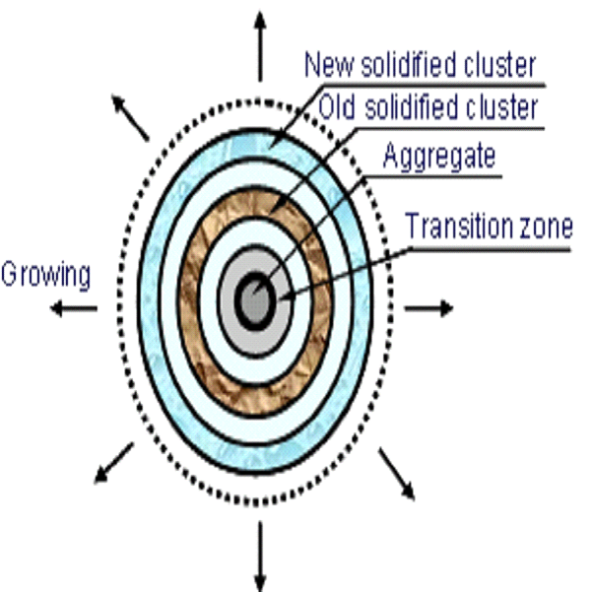
Fig.1 presents the schematic representation of hydration solidification

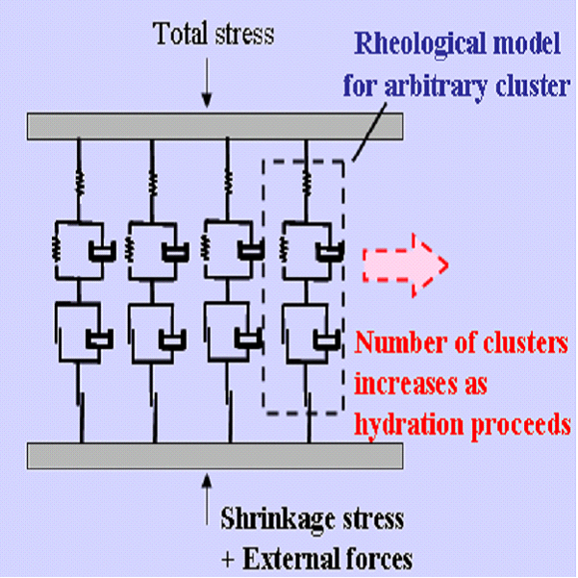
process
Fig.2 shows the number of clusters increases as proceeds

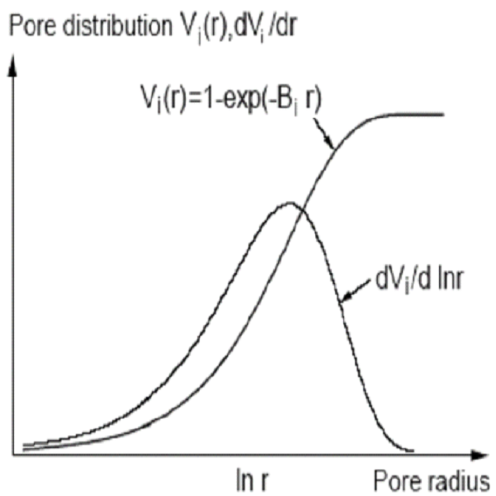
Fig.3 is the cumulative distribution function and density function for the porosity diagram
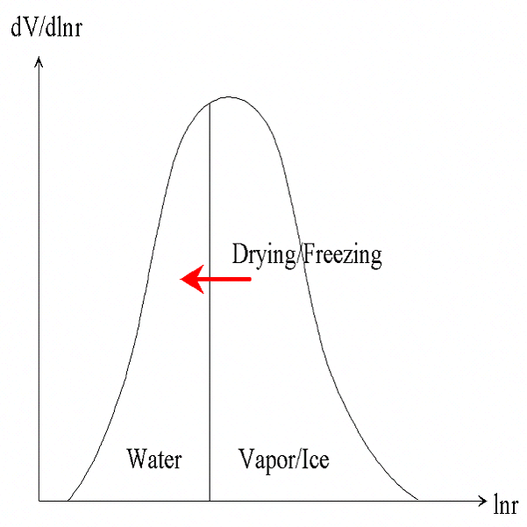

Fig.4 is the freezing or drying in pore distribution (volume/logarithmic radius of pores)
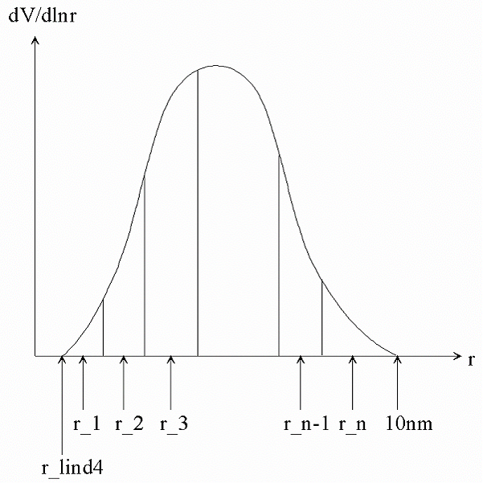

Fig.5 is the proposed density function of micro pores
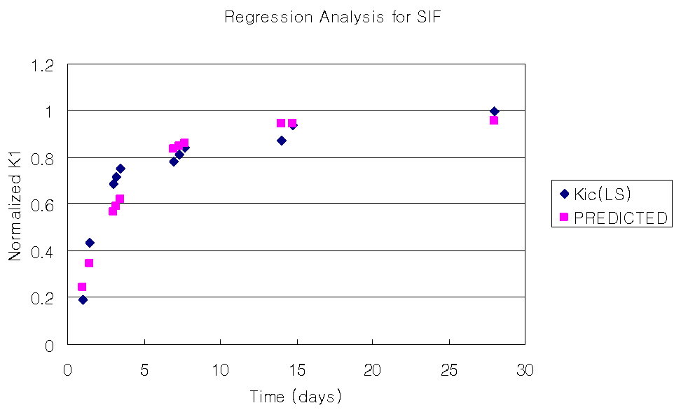
Fig.6 is the obtained stress intensity factor from experimental results

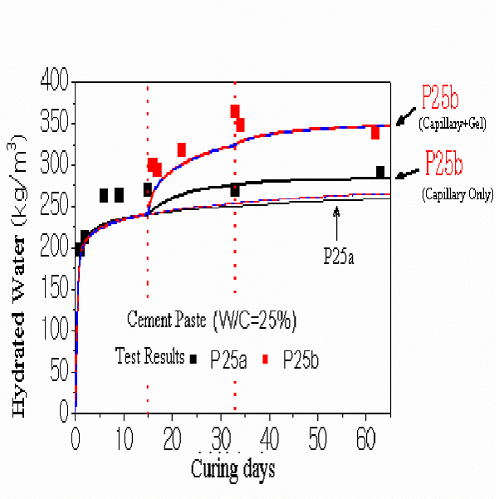
Fig.7 The results of analysis and experiments for additional hydration

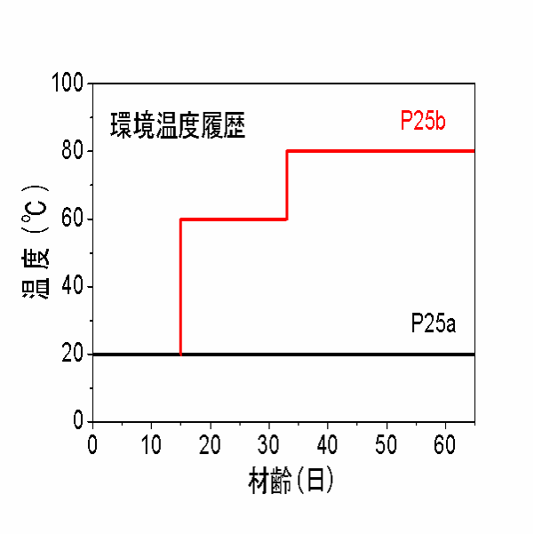
Fig.8 The temperature history for the experiments

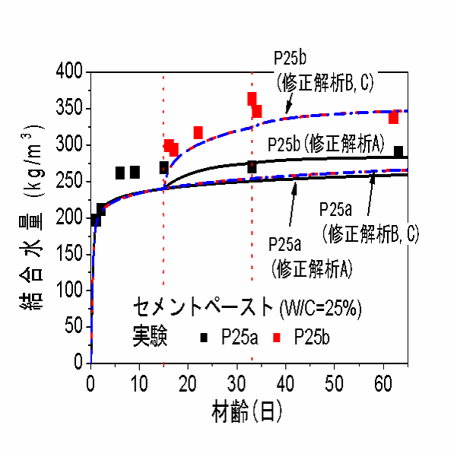
Fig.9 The time dependent bound water (by analysis and experimental results）
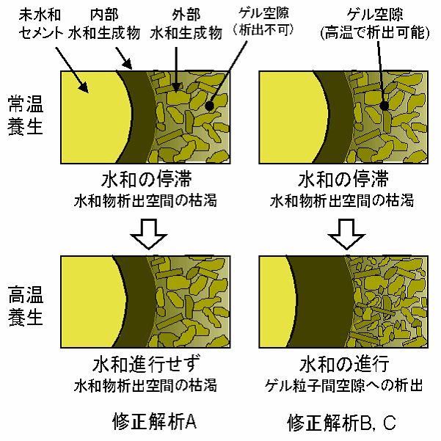
Fig.10 The formation of pore volume with cured in high temperature after cured in room temperature

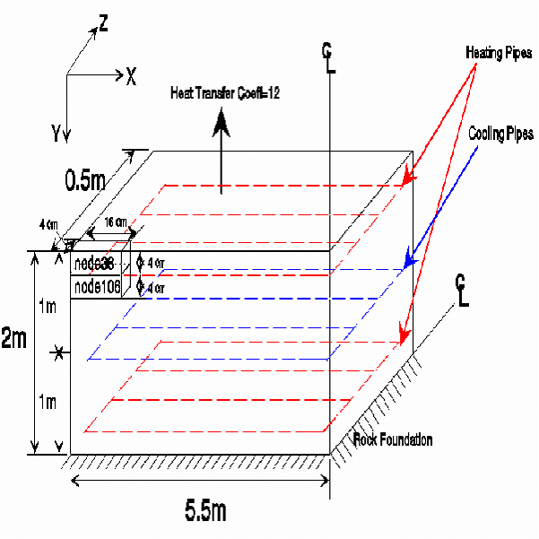
Fig.11 The boundary condition and locations for measurement (Element Numbers)
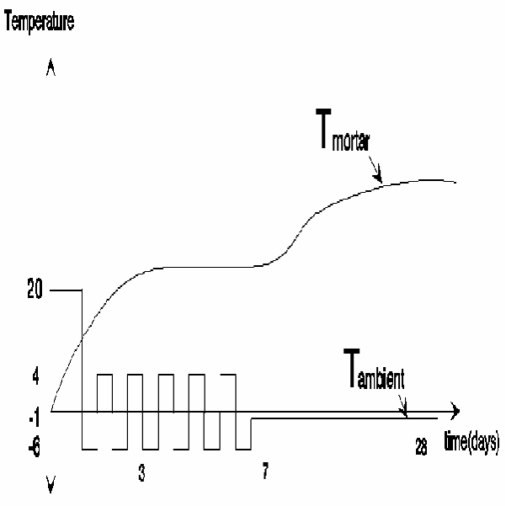
Fig. 12 The ambient temperature history

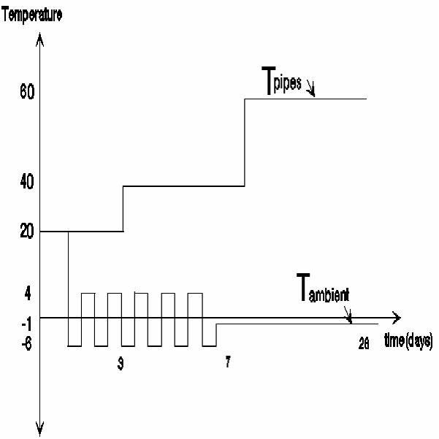
Fig.13 The temperature of all (heating and cooling) Pipes

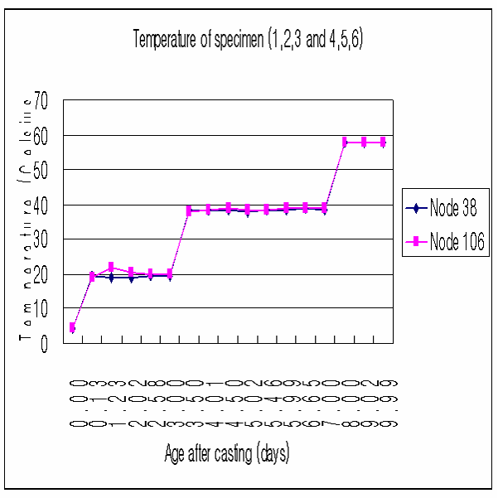
Fig. 14 The temperature of heated specimen
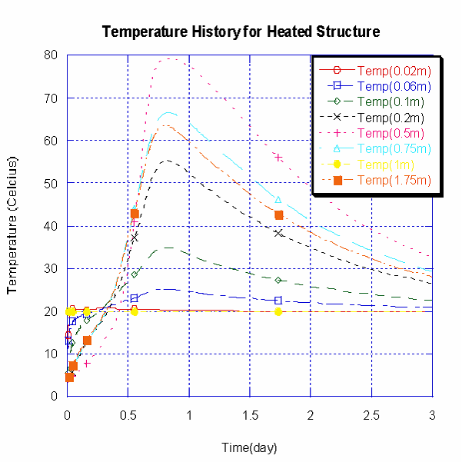
Fig. 15 The temperature of specimen (cured date: 0-3)

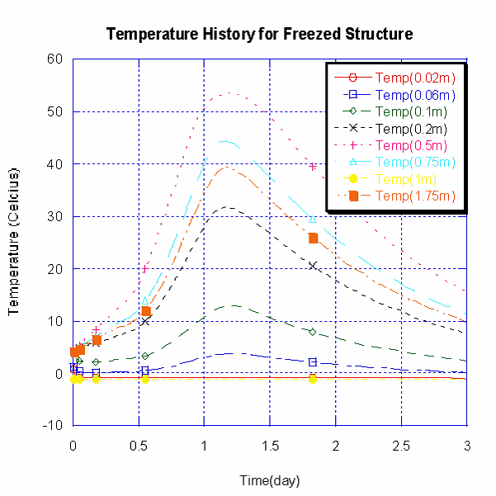
Fig. 16 is the temperature of frozen specimen (cured date: 0-3)
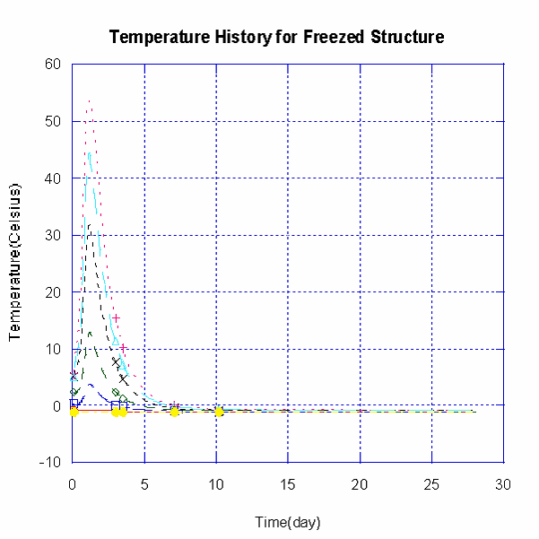
Fig. 17 The temperature of frozen specimen (cured date: 0-28)
Temperature distribution at 7.6752days
(From surface of X axis: C,B,D,E,F,G,H,I,J,K,L)

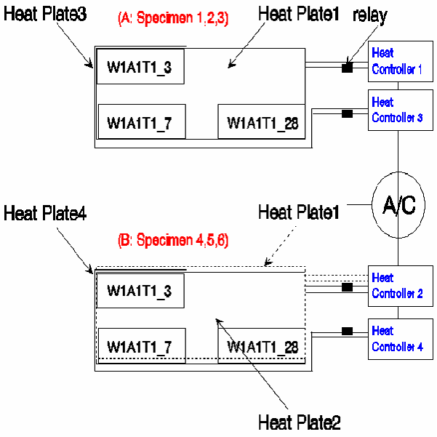
Fig. 18 The name of the specimens (w/c, EA, Temperature, order of measurement)
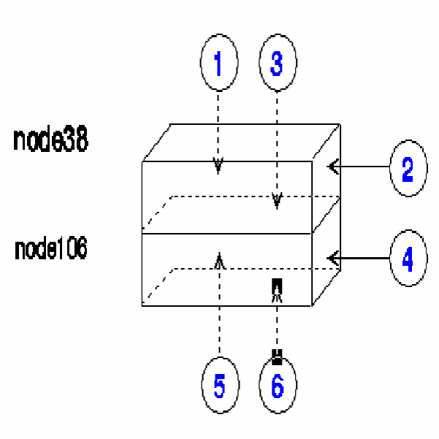
Fig.19 The exposed surfaces of the heated specimen
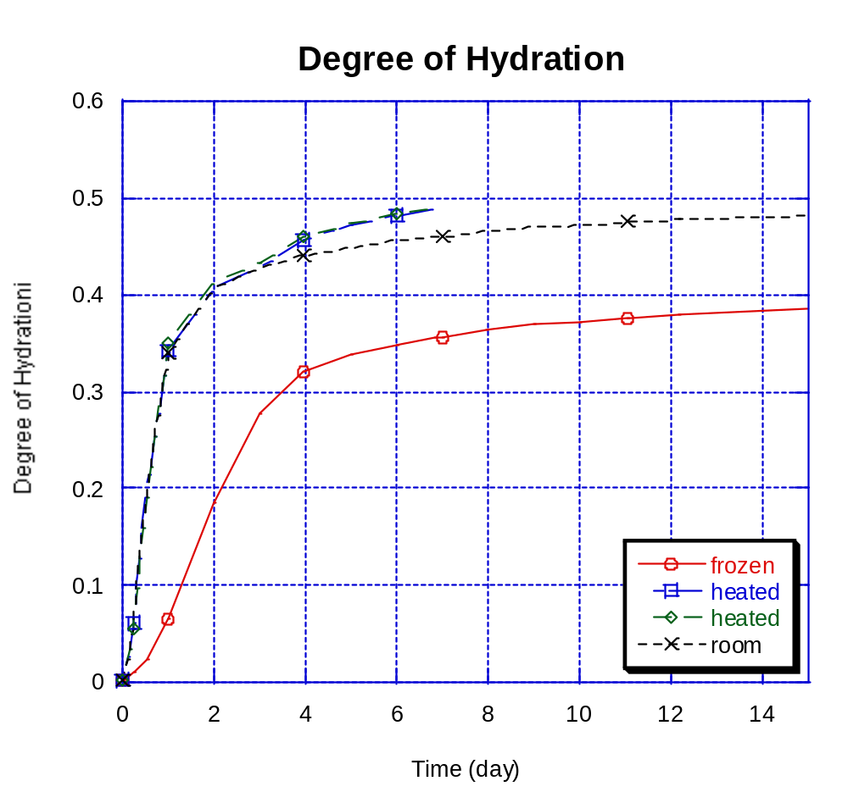
Fig.20 The degree of hydration for the tested specimens
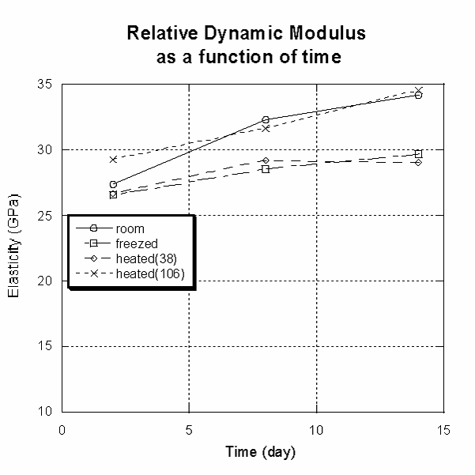
Fig.21 The measured results for relative dynamic modulus
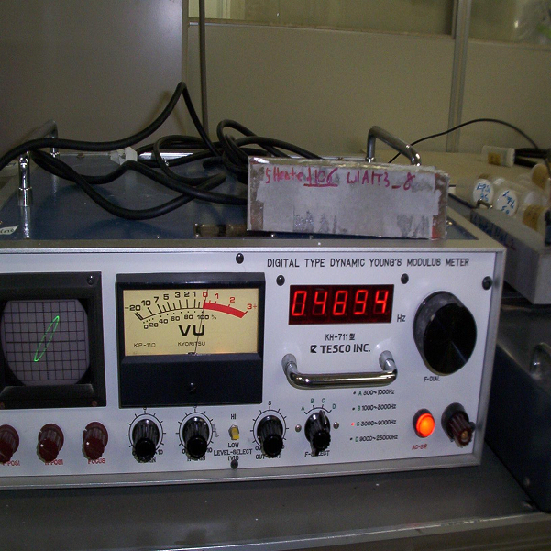
Fig.22 The natural frequency of heated specimen (Node 106), 8th date of curing
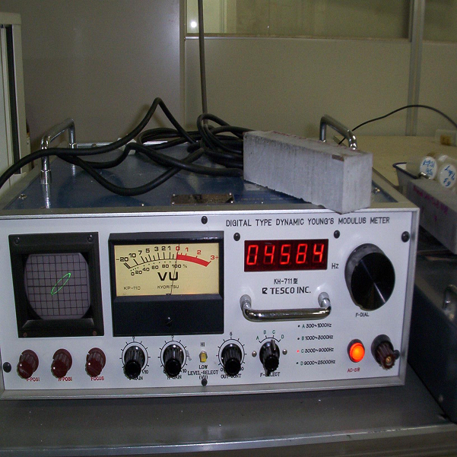
Fig.23 The natural frequency of heated specimen (Node 38), 8th date of curing

