Economic efficiency of crop production in France by DEA, 1989-2006
Lucyna Błażejczyk-Majka
Institute of History, Adam Mickiewicz University, Poland; majkal@amu.edu.pl
Radosław Kala
Department of Mathematical and Statistical Methods, Poznań University of Life Sciences, Poland; kalar@up.poznan.pl

Abstract: In this paper the economical efficiency of crop production in French agriculture is analyzed. The investigations were conducted using data envelopment analysis oriented on inputs saving. It is based on panel data covering the years 1989-2006 and concerns average farms on the regional level. As a result some dependence of economical efficiency on the proportions of major directions of crop production was observed and the effects of successive CAP reforms on efficiency changes are indicated.
Key words: DEA, French agriculture, economical efficiency, CAP reforms

Introduction
The problem of a measure of productive efficiency and productivity has been the focus of attention for economists at least since the early papers by Debreu [6]) or Farrell [9]. In case of agricultural production this issue is especially complicated not only because of the instability of meteorological conditions, having a crucial influence on farming, but also due to the large variability of farms with respect to their sizes and production profiles. In this paper we make an attempt to evaluate the economical efficiency of crop production in French agriculture. This choice was motivated by the fact that France is one of the biggest European agricultural producers and it plays a key role in organizing and reforming the Common Agricultural Policy (CAP) in the UE. The applied approach was based on the data envelopment analysis (DEA) with the use of panel data covering the years 1989-2006.
In Section 2 some details of DEA as well as some measures of efficiency are generally described. In Section 3, the data set is characterized, while in Section 4 the main results following from the DEA are presented. Some general conclusions are summarized in the last section.

Data envelopment analysis
DEA is a non-parametric approach based on linear programming, in which the economic efficiency of any producer, in a given group of them, is evaluated by comparing the observed vectors of inputs and outputs. A particular formulation of the linear program depends on initial assumptions. They concern the type of orientation, which can be focused on output maximization given the values of inputs or on input minimization given the values of outputs, and the type of technology restrictions, which can be constant return to scale (CRS) or variable return to scale (VRS).
In the case of constant return to scale and input oriented DEA, an estimate of the index of technical efficiency is obtained by solving a linear program of the form:
Min_{θ,λ} θ; subject: –y_{i} + Yλ ≥ 0, θx_{i} – Xλ ≥ 0, λ ≥ 0, (1)
where x_{i} and y_{i} represent vectors of inputs and outputs, respectively, of the i-th producer, while X and Y are matrices of input and output vectors of all producers in the sample. The estimated technical efficiency of the i-th producer, TE_{ci}, is the optimal value of θ solving problem (1). When TE_{ci} is equal to one, the i-th producer is called the frontier, i.e. it is the most efficient in the whole sample under consideration. If TE_{ci} < 1, then the producer could possibly reduce the usage of all inputs proportionally to the value of θ without reducing outputs. For a more detailed discussion of productivity and efficiency measures, their interpretation and properties, see the monograph edited by Fried, Lovell and Schmidt [10].
Replacement of the constant return to scale restriction by variable return to scale technology results in supplementing (1) by an additional condition that all λ’s sum to one. This convexity constrain envelops the data set more tightly, which now is covered by the convex hull rather than the convex cone only, as in the case of constant return to scale. The corresponding estimate of technical efficiency TE_{vi} in not less than TE_{ci}, and their ratio, TE_{ci},/ TE_{vi}, is known as the scale efficiency index (see e.g. [3]).
In the case of panel data it is also possible to estimate various efficiency change indexes. The simplest one is the ratio of two efficiency scores corresponding to two successive periods,
EC_{i}(t,t +1) = TE_{i}(t +1|t +1)/ TE_{i}(t|t), (2)
where TE_{i}(r|s) denotes the technical efficiency score of the i-th producer considered in period r respective to the period s benchmark technology. The other possibilities are as follows:
EC_{i}(t) = TE_{i}(t +1|t)/ TE_{i}(t|t),
EC_{i}(t +1) = TE_{i}(t +1|t +1)/ TE_{i}(t|t +1),
where EC_{i}(t) evaluates the efficiency change with respect to the technology of period t, while EC_{i}(t +1) does the same, but with respect to the technology of period t +1. The geometrical mean of the above indexes leads to the Malmquist index. All these measures of efficiency change, if greater than one, indicate the efficiency growth between periods t and t +1, but each of them does it in a different way. Index (2) measures the contribution of technical efficiency change to productivity and is invariant with respect to any nonsingular transformation of data vectors. The next indexes measure the influence of technical change on productivity and they are also invariant to nonsingular transformations, but only in the case when the transformation is the same in two successive periods.

Data
Investigations were conducted based on statistical data made available by the European system of gathering accounting data from farms (Farm Accounting Data Network, FADN; [19]). The FADN system is focused first of all on the biggest commercial farms, which jointly produce in a given region or country at least 90% standard gross margin (SGM). The total value of standard gross margins in individual types of farming activity makes it possible to determine the economic size of the farm, which is expressed in European size units (ESU). In turn, the highest of margin values make it possible to define the specialization of a farm by classifying it to one of the eight types, i.e. Field crops, Horticulture, Wine, Other permanent crops, Milk, Grazing livestock, Granivores and Mixed (crops and livestock).
The FADN system makes available data on farms at different levels of aggregation. This study used data aggregated at the regional level, with only those regions being included in the analyses, in which there were - in each year of the period of 1989-2006 - farms specialized in crop production. Since the FADN system does not provide data concerning farms with such a wide profile, an additional aggregation of farms of four types, i.e. Field crops, Horticulture, Wine and Other permanent crops, was conducted. As a result, each of the following regions, i.e. Île de France (121 – the region number in the FADN system), Champagne-Ardenne (131), Picardie (132), Haute-Normandie (133), Centre (134), Basse-Normandie (135), Bourgogne (136), Nord-Pas-de-Calais (141), Lorraine (151), Alsace (152), Pays de la Loire (162), Bretagne (163), Poitou-Charentes (164), Aquitaine (182), Midi-Pyrénées (183), Rhônes-Alpes (192); Auvergne (193), Languedoc-Roussillon (201) and Provence-Alpes-Côte (203), was represented by one average farm specializing in crop production.
Due to the aggregate character of variables describing agriculture, an approach typically used in literature is to express labour in annual work physical units (AWU), while the volume of incurred inputs and resultant variables are presented in terms of values (see e.g. [2]; [8]; [4]). The transformation of aggregate variables in quantitative indexes is usually very complex and respective statistical data need to be available (see e.g. [1]). For this reason in the conducted investigations all variables were expressed in values. The resultant variable was the value of total crop production (SE135 – the variable symbol in the FADN system), which category comprises sales of crop products, the variation of store balance of crop products, crops products for farm use and farmhouse consumption of crop products. It needs to be stressed that the value of total crop production determined in this way is not affected by subsidies and direct payments.
Due to the importance of the human factor in agricultural production, labour and the other current inputs were assumed to be inputs in agricultural production. These variables in the FADN system are expressed in values, with wages paid (SE370) being included in total inputs (SE270), which additionally comprise total specific costs (SE281), overheads (SE336), depreciation (SE360) and external factors (SE365). In this situation current inputs were isolated from total inputs by deducting labour, which in turn includes wages and social security charges (and insurance) of wage earners.
Although according to the DEA methodology technical efficiency should be determined based on quantitative variables, the use of variables expressed in values does not cause disurbances if it is limited to the determination of technical efficiencies TE_{ci}, TE_{vi} and the index of technical efficiency change given in (2). It follows from their invariance with respect to the nonsingular transformations. As a consequence, however, this means that determined indexes pertain to economic efficiency, and not technical efficiency. The usefulness of the indexes of technical change, and the Malmquist index in particular, depend on price changes between successive periods (see e.g. [10]). However, in view of the fact that investigations were limited to French agriculture, where according to EUROSTAT in the period of 1997-2007 mean inflation rate was 1.64%, it may be expected that also these indexes well illustrate the dynamics of changes.

Results
Because of the food safety policy, which in the EU countries has led to considerable food overproduction (see e.g. [7], [14]), in this investigations we use the input oriented version of DEA. Calculations were made using the DEAB computer programme. More information on this programme can be obtained from the Centre for Efficiency and Productivity Analysis (CEPA, [18]).
Table 1. Estimated economic efficiencies TE_{vi} from variable return to scale and input oriented DEA
Region | 1989 | 1990 | 1991 | 1992 | 1993 | 1994 | 1995 | 1996 | 1997 | 1998 | 1999 | 2000 | 2001 | 2002 | 2003 | 2004 | 2005 | 2006 | Mean
(201) | 1.00 | 1.00 | 1.00 | 1.00 | 1.00 | 1.00 | 1.00 | 1.00 | 1.00 | 1.00 | 1.00 | 1.00 | 1.00 | 1.00 | 1.00 | 1.00 | 1.00 | 1.00 | 1.00
(151) | 0.99 | 1.00 | 1.00 | 1.00 | 1.00 | 1.00 | 1.00 | 1.00 | 1.00 | 1.00 | 1.00 | 1.00 | 1.00 | 1.00 | 1.00 | 1.00 | 1.00 | 1.00 | 1.00
(131) | 1.00 | 1.00 | 1.00 | 1.00 | 1.00 | 1.00 | 1.00 | 1.00 | 1.00 | 1.00 | 1.00 | 0.95 | 1.00 | 1.00 | 1.00 | 1.00 | 1.00 | 1.00 | 1.00
(203) | 1.00 | 0.91 | 0.97 | 1.00 | 1.00 | 1.00 | 1.00 | 1.00 | 1.00 | 1.00 | 1.00 | 1.00 | 1.00 | 1.00 | 1.00 | 1.00 | 1.00 | 1.00 | 0.99
(152) | 0.94 | 0.90 | 1.00 | 1.00 | 1.00 | 1.00 | 0.94 | 1.00 | 1.00 | 1.00 | 1.00 | 1.00 | 1.00 | 1.00 | 1.00 | 1.00 | 1.00 | 0.98 | 0.99
(193) | 1.00 | 1.00 | 1.00 | 1.00 | 0.99 | 1.00 | 1.00 | 1.00 | 1.00 | 1.00 | 1.00 | 1.00 | 0.89 | 0.88 | 0.93 | 1.00 | 0.95 | 1.00 | 0.98
(164) | 0.99 | 1.00 | 1.00 | 0.96 | 0.87 | 0.92 | 1.00 | 0.95 | 0.95 | 0.95 | 1.00 | 0.98 | 1.00 | 1.00 | 1.00 | 1.00 | 1.00 | 1.00 | 0.98
(132) | 0.71 | 0.83 | 0.86 | 1.00 | 1.00 | 1.00 | 1.00 | 1.00 | 1.00 | 1.00 | 1.00 | 1.00 | 1.00 | 1.00 | 1.00 | 1.00 | 1.00 | 1.00 | 0.97
(183) | 0.92 | 0.97 | 1.00 | 0.86 | 1.00 | 0.86 | 0.89 | 1.00 | 1.00 | 1.00 | 1.00 | 1.00 | 0.97 | 0.87 | 1.00 | 1.00 | 1.00 | 1.00 | 0.96
(192) | 1.00 | 0.93 | 0.98 | 0.89 | 0.99 | 0.94 | 0.95 | 0.89 | 0.90 | 0.92 | 0.84 | 0.91 | 0.94 | 0.94 | 0.95 | 0.95 | 0.98 | 0.95 | 0.94
(141) | 0.72 | 0.73 | 0.76 | 0.87 | 0.92 | 1.00 | 1.00 | 0.94 | 0.95 | 1.00 | 1.00 | 1.00 | 1.00 | 1.00 | 1.00 | 0.98 | 0.84 | 0.90 | 0.92
(136) | 0.91 | 0.91 | 0.83 | 0.81 | 0.96 | 0.96 | 0.98 | 0.97 | 1.00 | 0.96 | 0.90 | 1.00 | 1.00 | 0.95 | 0.90 | 0.85 | 0.84 | 0.84 | 0.92
(163) | 0.75 | 0.76 | 0.71 | 1.00 | 1.00 | 1.00 | 0.98 | 0.86 | 0.83 | 0.85 | 0.74 | 1.00 | 1.00 | 0.85 | 0.98 | 0.78 | 0.80 | 0.82 | 0.87
(121) | 0.85 | 0.94 | 1.00 | 1.00 | 1.00 | 0.92 | 0.81 | 0.81 | 0.83 | 0.80 | 0.77 | 0.77 | 0.78 | 0.83 | 0.88 | 0.78 | 0.81 | 0.99 | 0.86
(182) | 0.83 | 0.79 | 0.78 | 0.93 | 0.77 | 0.77 | 0.87 | 0.89 | 0.87 | 0.92 | 0.87 | 0.84 | 0.80 | 0.79 | 0.82 | 0.82 | 0.83 | 0.84 | 0.83
(135) | 0.69 | 1.00 | 0.74 | 0.83 | 0.82 | 0.79 | 0.75 | 0.72 | 0.77 | 0.86 | 0.91 | 0.81 | 0.88 | 0.86 | 0.81 | 0.84 | 0.84 | 0.83 | 0.82
(133) | 0.69 | 0.71 | 0.73 | 0.84 | 0.72 | 0.95 | 0.86 | 0.76 | 0.83 | 0.86 | 0.80 | 0.86 | 0.83 | 0.90 | 0.93 | 0.76 | 0.77 | 0.85 | 0.81
(134) | 0.82 | 0.78 | 0.86 | 0.77 | 0.82 | 0.82 | 0.80 | 0.73 | 0.78 | 0.82 | 0.80 | 0.80 | 0.78 | 0.82 | 0.82 | 0.80 | 0.80 | 0.80 | 0.80
(162) | 0.84 | 0.74 | 0.81 | 0.75 | 0.84 | 0.80 | 0.81 | 0.74 | 0.78 | 0.76 | 0.74 | 0.75 | 0.74 | 0.80 | 0.83 | 0.75 | 0.76 | 0.80 | 0.78
Mean | 0.88 | 0.89 | 0.90 | 0.92 | 0.93 | 0.93 | 0.93 | 0.91 | 0.92 | 0.93 | 0.91 | 0.93 | 0.93 | 0.92 | 0.94 | 0.91 | 0.91 | 0.93 | 0.92

Figure 1. Economic efficiency of regions of France in terms of crop production
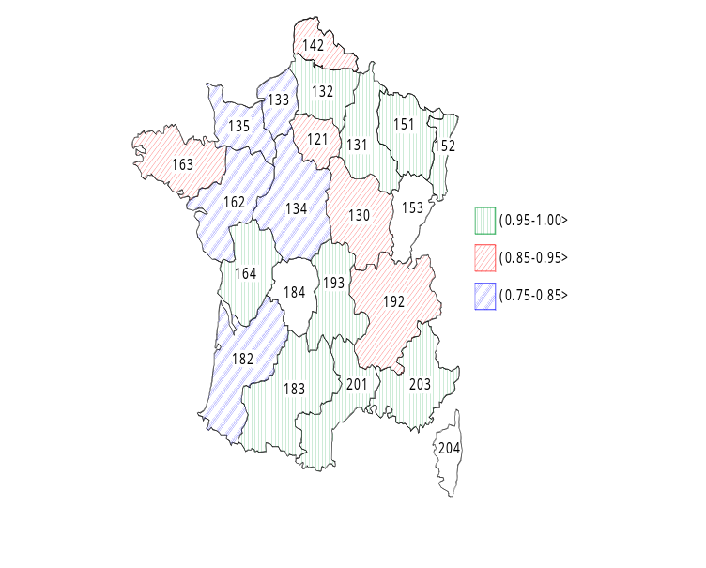
Table 1 presents values of economic efficiencies established assuming variable return to scale. The first column gives the denotation of regions, which were ordered according to the mean value of their economic efficiency. Throughout the entire analyzed period the most efficient farms were those from the Languedoc-Roussillio region (201), located in the south of France, while the least efficient were farm from the Pays de la Loire region (162), in north western France. Based on the obtained results it may be stated that farms from almost 1/2 analyzed regions in France reported on average at least 95% economic efficiency in relation to the best farms. In the next five regions efficiency ranged from 85% to 95% maximum efficiency, while in the other regions efficiency was lowest, although not less than 75%. In what follows we will focus on the three groups of regions mentioned above. The geographical locations of investigated regions are presented in Fig. 1, while more detailed economic characteristics are given in Table 2.
Table 2. Selected characteristics of regions of France in terms of crop production
Region |  | Economic size | Total labour input | Total  Utilised Agricultural Area | Total Inputs | Percentage of crop production
 |  |  |  |  |  | Field crops | Horti-  culture | Wine | Other permanent crops
 |  | (ESU) | (AWU) | (ha) | (1000 €) | (%) | (%) | (%) | (%)
Languedoc-Roussillon | (201) | 51.35 | 1.89 | 24.84 | 68.69 | 1.00
Lorraine | (151) | 85.23 | 1.57 | 153.97 | 126.93 | 0.37 |  | 0.63
Champagne-Ardenne | (131) | 97.51 | 1.88 | 66.30 | 123.18 | 0.17 | 0.34 | 0.24 | 0.25
Provence-Alpes-Côte | (203) | 67.96 | 2.82 | 23.45 | 96.29 | 0.32 |  | 0.68
Alsace | (152) | 58.74 | 1.91 | 33.95 | 85.58 | 1.00
Auvergne | (193) | 46.87 | 1.42 | 78.11 | 77.40 | 0.37 |  | 0.63
Poitou-Charentes | (164) | 58.27 | 1.56 | 72.80 | 80.97 | 0.90 |  | 0.10
Picardie | (132) | 108.74 | 1.76 | 116.86 | 154.65 | 0.19 |  | 0.36 | 0.45
Midi-Pyrénées | (183) | 46.22 | 1.74 | 61.78 | 71.92 | 0.12 | 0.40 | 0.25 | 0.24
 | Mean | 68.99 | 1.84 | 70.23 | 98.40 | 0.49 | 0.08 | 0.32 | 0.10
Rhônes-Alpes | (192) | 52.54 | 2.17 | 30.18 | 80.06 | 0.12 | 0.40 | 0.25 | 0.24
Nord-Pas-de-Calais | (141) | 72.85 | 1.70 | 64.78 | 108.26 | 0.78 | 0.22
Bourgogne | (136) | 89.26 | 1.89 | 88.49 | 121.06 | 0.34 |  | 0.66
Bretagne | (163) | 48.58 | 2.27 | 33.24 | 109.24 | 0.28 | 0.72
Île de France | (121) | 95.43 | 1.69 | 114.62 | 132.93 | 0.43 | 0.57
 | Mean | 71.73 | 1.94 | 66.26 | 110.31 | 0.39 | 0.38 | 0.18 | 0.05
Aquitaine | (182) | 76.47 | 2.34 | 36.47 | 106.32 | 0.17 | 0.15 | 0.51 | 0.18
Basse-Normandie | (135) | 75.09 | 1.68 | 89.48 | 113.96 | 0.45 | 0.55
Haute-Normandie | (133) | 92.57 | 1.72 | 112.65 | 140.03 | 1.00
Centre | (134) | 79.62 | 1.68 | 105.24 | 113.93 | 0.22 | 0.25 | 0.35 | 0.19
Pays de la Loire | (162) | 72.83 | 2.23 | 51.28 | 110.93 | 0.14 | 0.52 | 0.24 | 0.10
 | Mean | 79.32 | 1.93 | 79.02 | 117.03 | 0.39 | 0.29 | 0.22 | 0.09

Based on values given in Table 2 we may first of all observe that economic size, the utilized agricultural area as well as labour input did not have any major effect on economic efficiency of farms. The first group comprised both very large farms, economically and in terms of their size, located in north-eastern France in the Champagne-Ardenne (131), Picardie (132) and Lorraine (151) regions, and the smallest farms in the regions of southern France, i.e. Midi-Pyrénées (183) and Auvergne (193). The average employment rate was similar, although it was smallest in the first group. The same can be stated with respect to total inputs, but here the variation of regions in individual groups is very high. In turn, we need to stress here the specialization of farms. In the first group farms from seven out of nine regions are involved in viniculture, which is the leading activity for farms from three regions, i.e. Lorraine (151), Provence-Alpes-Côte (203) and Auvergne (193). In contrast, in the second and third groups, treated jointly, farms in eight out of ten regions are connected with horticultural production, which accounts for over 50% total production for farms in four regions: Bretagne (163), Île de France (121), Basse-Normandie (135) and Pays de la Loire (162).
Trends for economic efficiency throughout the entire period of 1989-2006 are presented in Fig. 2. The dynamics of this index depends on many different factors. These include climatic conditions, local weather conditions, natural disasters ([11]; [15]), novel technologies [12], the participation of the human capital, or the body of knowledge, public and private agricultural research ([16], [13]). Changes in these indexes may also be related with imposed regulations concerning the entire economy [14], [15], stages of transformation [4] and reforms resulting from CAP. Referring to French agriculture we will focus on the latter factor. A similar analysis, but in that case related to the economic size of Belgian farms specialized in field crop production, may be found in a study by Coelli et al. [2].
Figure 2. Dynamics of mean economic efficiency scores in groups
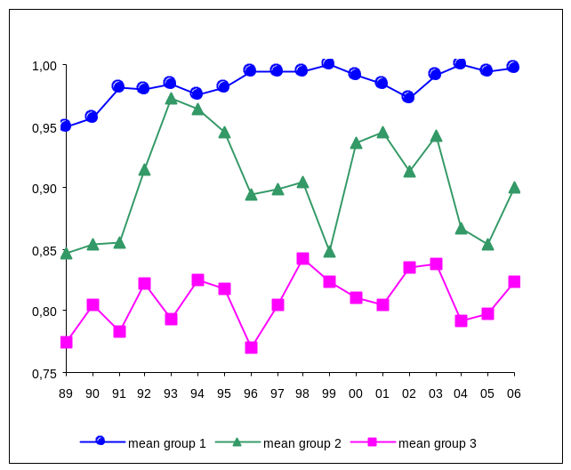
As it may have been expected, the most stable mean economic efficiency was observed for farms in regions from the first group, where efficiency was highest. In the second group fluctuations were biggest, while in the third group they were more moderate, although the upward trend, indicating a gradual improvement of efficiency, was maintained in all groups. The mean value of efficiency in the investigated period was 0.98 in the first group, 0.90 in the second group and 0.81 in the third group.
However, the increase in efficiency was not uniform over the entire analyzed period. It was most evident in the years 1989-1992. It needs to be stressed here that starting from 1985 the so-called Green Document was in force, introducing e.g. production quotas for cereals, fees for overproduction and fallowing, which resulted in improved efficiency of crop production (see e.g. [5], [17]) or a search for more profitable types of production on the part of farmers. In turn, in the following years, 1992-1996, we may observe a decrease of economic efficiency in the second and third groups. At that time elements of the MacSharr reforms started to be implemented. Administrative actions consisted mainly in the introduction of price stabilizers, i.e. the determination of levels of production, which when exceeded would result in a reduction of price guarantees. Moreover, direct compensations for producers were also applied, which removed the interdependence of the level of production on market prices. Following changes may be connected with stages of realization of Agenda 2000. This reform was aimed to increase the role of direct payments and made a reduction of utilized agricultural area as a pre-condition for obtaining compensation subsidies. As a consequence, even in the group of the best regions a period of deteriorated efficiency was observed, followed again by a period of growth. In the two other groups of regions, particularly in the second group, a marked destabilization was evident.
Figure 3. Dynamics of mean economic efficiency change index
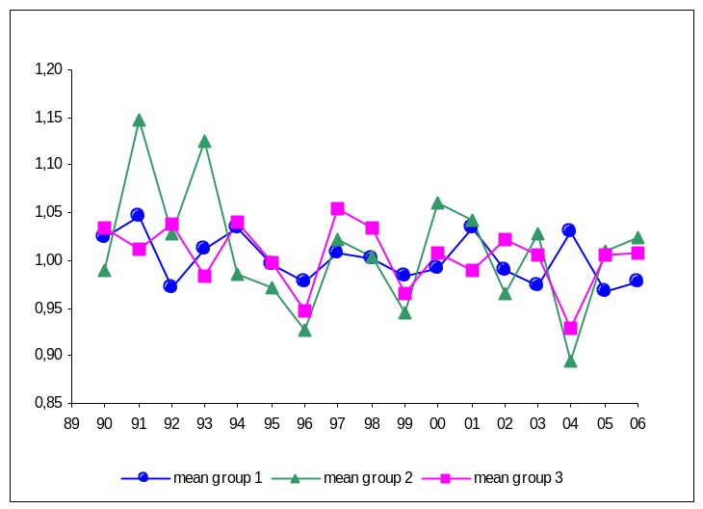
Figure 3 presents graphs of dynamics for the efficiency change index defined by formula (2). This graph confirms the biggest instability of economic efficiency in farms from regions classified to the second group and relatively the smallest fluctuations in the first group.

Conclusions
The paper presented an analysis of crop production efficiency in France at the regional level. Due to the high overproduction of certain foodstuffs in the EU, as well as agricultural policy realized for many years and aiming at the reduction of economic consequences for such a situation, the Data Envelopment Analysis with the minimization of input consumption was applied in the study. In the investigations the resultant variable was the value of crop production, while production factors were labour and other direct inputs, which variables were also expressed as values. As a result, determined indicators need to be treated as economic efficiencies.
Values of economic efficiency estimated for average farms in different regions of France show that almost 50% farms were characterized by efficiency of at least 95% maximum economic efficiency reported in the years 1989-2006. The lowest mean efficiency in the investigated period, recorded for Pays de la Loire (162), amounted to 0.78% efficiency reached by the most efficient regions, i.e. Languedoc-Roussillon (201), Lorraine (151) and Champagne-Ardenne (131).
Conducted investigations do not make it possible to link economic efficiency with the size of farms or the number of full-time employees. However, we need to stress the dependence of economic efficiency on the proportions of major directions of production in the total value of crop production. In the group of ten most efficient French regions, in as many as seven wine production plays a considerable role, and for farms from three regions, i.e. Lorraine (151), Provence-Alpes-Côte (203) and Auvergne (193) being the leading type of production. In turn, farms in eight out of the ten other regions were involved in horticultural production, which in farms from four regions: Bretagne (163), Île de France (121), Basse-Normandie (135) and Pays de la Loire (162), was the activity accounting for more than 50% total. It may also be observed that among the four discussed direction of production farms specializing in viniculture generally showed higher efficiency than horticultural farms.
Based on the analysis of dynamics of economic efficiency and established indexes of changes in these indicators a certain constant trend for the improvement of efficiency may be reported, indicating an increasingly better utilization of inputs. We may also observe the effect of successive CAP reforms on changes in efficiency in those farms. It may be generally stated that this effect was not uniform for all farms. The smallest changes were recorded in farms belonging to the group of the most efficient regions. Farms in the other two groups were characterized by a much higher variation in efficiency year by year, although in the group of more economically efficient regions these fluctuations were bigger than in the group of regions comprising the least efficient farms.

Acknowledgemets
This paper was supported by Funds for Sciences, 2008-2011, under grant # N N111 114034

References
[1] BALL V.E., BUREAU J.Ch., PBUTAULT J., NEHRING R. Levels of Farm Sector Productivity: An International Comparison. Journal of Productivity Analysis 15, 2001.
[2] COELLI T.J., PARELMAN S., VAN LIERDE D. CAP Reforms and Total Factor Productivity Growth in Belgian Agriculture: A Malmquist Index Approach. Contributed papers for the 26th Conference of the IAAE. 2006.
[3] COELLI T.J., RAO D.S.P., O’DONNELL C.J., BATTESE G.E. An introduction to efficiency and productivity analysis. Springer, 2005.
[4] CUNGU A., SWINNEN J.F.M. Transition and Total Factor Productivity in Agriculture. Working Paper of Katholieke Universiteit Leuven, 2003.
[5] CZYŻEWSKI A., HENISZ-MATUSZCZAK A. Agriculture in the European Union and Poland. A comparative study of manufacturing structures and regulators of agricultural markets. Wydawnictwo Akademii Ekonomicznej w Poznaniu, 2004. [in Polish].
[6] DEBREU G. The coefficient of resource utilization. Econometrica 19, 1951.
[7] DRUESNE G.. Substantive law and policies of Community and European Union. Wydawnictwo Naukowe Scholar, 1996. [in Polish].
[8] FÄRE R., GROSSKOPF S, MARGARITIS D. Productivity growth and convergence in European Union. Journal of Productivity Analysis 25, 2006.
[9] FARRELL M. The measurement of productive efficiency. Journal of the Royal Statistical Society A, General 120, 1957.
[10] FRIED H.O., LOVELL C.A.K., SCHMIDT S.S. The measurement of productive efficiency and productivity growth. Oxford University Press, 2008.
[11] GALLUP J.L., SACHS J.D. Agriculture, Climate, and Technology: Why Are the Tropics Falling Behind? Ammerican Journal of Agriculture Economics 82, 2000.
[12] GUTIERREZ L. Why is Agricultural Labour Productivity higher in some countries than others? Agricultural Economics Review 3 (1), 2002.
[13] HUFFMAN W., EVENSON R. New Econometric Evidence on Agricultural Total Factor Productivity Determinants: Impact and Funding Sources. Working Paper of Iowa State University. 2003.
[14] POCZTA W. Common Agricultural Policy in European Union. In: Agriculture farm in European Union. Costs and benefits. Fundacja na Rzecz Rozwoju Polskiego Rolnictwa. 2001. [in Polish]
[15] RUTTAN V.W. Productivity Growth in World Agriculture: Sources and Constraints. Journal of Economic Perspectives 16 (4), 2002.
[16] SCHULTZ T.W. Transforming Traditional Agriculture. Yale University Press. 1964
[17] The Common Agricultural Policy explained. European Commission. Agriculture and Rural Development. 2007. http://ec.europa.eu/agriculture/publi/capexplained/cap_en.pdf
[18] Centre for Efficiency and Productivity Analysis (CEPA) http://www.uq.edu.au/economics/cepa.
[19] Definitions of Variables used in FADN standard results. Community Committee for the Farm Accountancy Data Network (FADN). European Commission. Directorate-General for Agricultural and Rural Development. 2006. http://ec.europa.eu/agriculture/rica/index_en.cfm

