Estimation of an Asymmetric Stochastic Volatility Model for the EURO STOXX50 index returns and different Polish index returns.

García Centeno, María del Carmen (garcen@ceu.es)
Department of Quantitative Methods
San Pablo CEU University
Julián Romea, 23
28003-Madrid (Spain)

Mínguez Salido, Román (roman.minguez@uclm.es)
José Mondéjar Jiménez (Jose.Mondejar@uclm.es)
Statistics Department
Castilla-La Mancha University
Avda. de los Alfares, 44
16.071-Cuenca (Spain)

ABSTRACT
All the financial time series analyzed in this paper show the same stilyzed facts. The threshold asymmetric stochastic volatility (TA-ARSV) model is able to reproduce these stilyzed facts, such as, the daily returns are not correlated but the autocorrelation function of the squared returns presents a slow decreasing.
The volatility behaviour is very important in the Stock Market and the TA-ARSV model is able to explain the dynamic and asymmetric answer of the volatility when there are shocks of different sign (leverage effect). The objective of this paper is to detect the leverage effect in the different stock index returns: the EURO STOXX50 and four polish indexes.

Keywords: Leverage effect, Stochastic volatility, Stock returns.
JEL Category: C22, C51
1. INTRODUCTION
The volatility of the daily returns for some financial assets tends to change over time with persistence and it shows an asymmetric answer when there are shocks with different sign in the financial markets, that is, there is a negative correlation between correlation and this change in volatility. This stilyzed fact is known as “leverage effect” in the econometric literature and it is modelized, in the framework of discrete time, by an asymmetric autoregressive stochastic volatilility (A-ARSV) model, proposed by Harvey and Shephard (1996), which analyzed the leverage effects supposing that there is a negative correlation between the innovations of the conditional mean and the volatility equations.
The A-ARSV model is a generalization of the ARSV model, which was created by Taylor (1982, 1986), but in the framework of discrete time, the autoregressive conditional heteroskedasticity models (ARCH) modeled the dynamic of the volatility, see, Engle (1982).
The ARSV models are more appropiate to describe the dynamic of the volatility than the ARCH models, Carnero, et al. (2004). Therefore, we use a type of the asymmetric volatility model: the threshold autoregressive asymmetric stochastic volatility (TA-ARSV) model, developed by García (2008). This model is able to collect the asymmetric answer of the volatility, establishing a threshold, which indicates the behaviour of the volatility changes when there are shocks of different sign. The TA-ARSV model does not need to establish a correlation between the innovations of the returns and volatility equations, similar to the A-ARSV model, to capture the leverage effect. There are different orders of TA-ARSV model, but usually, a simple TA-ARSV(1) is adequated to explain the behaviour of different daily returns series used in this work.
The remainder of the paper is organized as follows. Section 2 defines the TA-ARSV(1) model. Section 3 expresses the TA-ARSV(1) model in state space form and the estimation of this model using the Monte Carlo Likelihood (MCL) method developed by Sandmann and Koopman (1998). Section 4 shows a contrast to detect the asymmetric answer of the volatility. Section 5 reports an empirical results for the five daily financial returns series, and section 6 provides some concluding remarks.

2. TA-ARSV(1) MODEL
The TA-ARSV(1) proposed to describe the dynamic of the volatility is defined by the following equations:
- The mean equation:
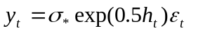ε_{t} ~ i.i.d N(0,1) (1)
- The log-volatility equation:
η_{t}~ i.i.d N(0,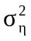) (2)
where,
- y_{t} are the returns calculated as follows: y_{t} = 100(log X_{t}- log X_{t-1}), where X_{t} is the index value at day t.
- 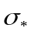 is a positive scale factor in the mean equation to avoid including a constant in the log-volatility equation .
- ε_{t} is a random disturbance (white noise) in the mean equation and it follows a Normal distribution with mean zero and variance one.
- 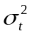 is the volatility and it is modelled as an exponential function to guarantee it is positive.
- h_{t} is the log-volatility. The equation (2) indicates that the log-volatility follows an AR(1) process in each regime.
- η_{t} is a white noise process in the log-volatility equation and it follows a Normal distribution with mean zero and variance 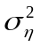.
- The distribution of ε_{t} and η_{t} are independent ∀t,s.
The asymmetric answer of the volatility is directly shown in the equation (2) and it lies in establishing a known threshold from which the parameters of the model change.
The modification is based on include the following changes in the log-volatility equation for an ARSV model to obtain the TA-ARSV model:
- Two new parameters: φ₁₁ and φ₁₂. The first measures the effect of the positive returns and the later measures the effect of the negative returns in the volatility.
- Two indicator variables: I₁ and I₂. These are defined as follows:
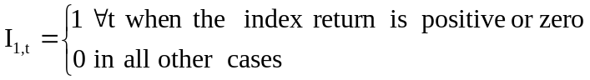
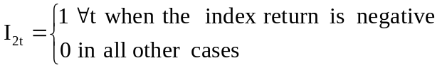
The equation (2) shows the dynamic of the log-volatility and it is defined for two different regimes (one for positive or zero returns and another for negative returns) rule out each other, as only one of them can happen at the same time. In this sense, the equation (2) establishes the log-volatility depending on, both, its immediate past value and the sign of the returns in the previous period.
Therefore, the TA-ARSV(1) model is a generalization of the ARSV(1) model, including an additional parameter which allows the model to explain the asymmetric asnwer of the volatility.
The following section develops the TA-ARSV(1) model represented in state space form.

3. THE TA-ARSV (1) MODEL REPRESENTED IN STATE SPACE FORM.
The volatility is defined as an exponential function in the TA-ARSV(1) model shown in the equations (1) and (2), thus, this model is not linear. However, the model can be expressed as a linear model squaring the mean equation and taking logarithms in both sides of the equation (1). So, we obtain a simple model similar to the proposed by Sandmann and Koopman, (1998) for models with a little or null change in the mean and high dependence on covariance.
The transformed model is:
- The mean equation:
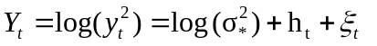 (3)
- The volatility equation:
η_{t} i.i.d. N(0,) (4)
The equation (3) shows that the squared returns logarithm is obtained adding a constant and two independent stochastic processes. These processes are:
- The volatility (h_{t}), which is a stationary linear process; and,
- The random disturbance (ξ_{t}), which has a 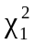 distribution, because the disturbances of mean equation follow a N(0,1) distribution.
This equation, in a model expressed in state space form, would be the measurement equation beacause it relates the observed variable (the returns) with the unobserved or state variable (the volatility).
The equation (4) represents the dynamic of the volatility along the time. This behaviour of the volatility depending on:
- The regime to be produced in each instant (which depends on the index stock return sign in the previous period).
- The volatility value in the previous period.
- And, finally, the innovation follows a Normal distribution with mean zero and variance . Moreover, it is assumed these disturbances are uncorrelated with the mean equation disturbances, E(ξ_{t},η_{t})=0.
This equation, in state space form, would be the transition equation. It shows the dynamic evolution of the states.
The model in the equations (3) and (4) is a linear model and it can be directly cast in state space form as follows:
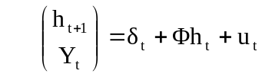
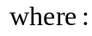
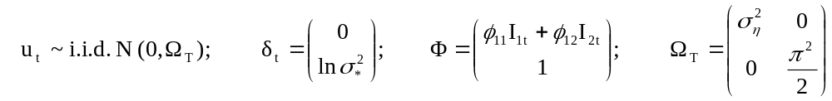
The likelihood function for a TA-ARSV(1) model, which is a non gaussian model, is easier to evaluate using the Monte Carlo method approximating the non gaussian model by importance sampling.
The next section develops some tests for detecting the asymmetric answer of the volatility.

4. CONTRASTS
The leverage effect could be detected using a test with a null hypothesis: Ho:φ₁₁=φ₁₂ (both regimes with equal coefficients) and alternative hypothesis: H₁: φ₁₁ ≠ φ₁₂. This test encompasses as the ARSV(1) model, in the null hypothesis, as the TA-ARSV model in the alternative hypothesis.
A good possibility to implement the test is using the likelihood ratio contrast 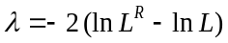. We can apply this ratio because the test nests both models.
If the null hypothesis is not rejected, then there will be no evidence of an asymmetric answer of volatility. In this case the ARSV(1) model could be preferred. On the other hand, if the null hypothesis is rejected, the dynamic effect in the volatility for a negative or positive shock is different. For all daily financial returns series examined in this work this effect is bigger when the shocks are negative, because the estimated value of the φ₁₂ parameter is bigger than the φ₁₁ parameter. In this case the TA-ARSV(1) model could be adequated.
5. EMPIRICAL EVIDENCE
This section examines if the TA-ARSV(1) model is adequated to explain the asymmetric answer of the volatility and their advantages in comparison with the ARSV(1) model.
The analysis is based on two points:
a) To detect if the leverage effect exists o not;
b) The persistence in the volatility.
The analysed data correspond to five daily stock index returns namely, Warsaw General Index 20 (POLWG20); Warsaw MWIG40 (POLWG40); Warsaw General Index (POLWIGI); Warsaw SWIG80 (POLWIRR) and the DJ EURO STOXX 50 (EUROSTOXX50). The Table 1 summaries some information about these indexes and their returns.
The POLWIGI index financial returns will be used to explain the main stylized fact of the return series (in this work, the rest of used indexes have the same characteristics). These stylized facts are: a) The volatility clusters, Figure 1(b), because there are some periods in which exist consecutives values with high volatility (which coincide with periods in which the variation of index stock returns is bigger) alternating with other periods where the volatility is lower; b) The autocorrelation function in this case, Figure 1(d), shows no time dependence in mean, because their coefficients are not significant; c) The volatility clusters imply, in statistical terms, that there is a positive correlation in the squared returns. In this way, if the volatility is high in a period, it tends to be high in the next one, and conversely, if the volatility is low in a period, it tends to be low in the next one. The autocorrelation function of squared returns, Figure 1(e), due to the existence of volatility clusters, shows a strong dependence structure which is shown by significant positive correlations. In the majority of time series, these positive correlations decrease slowly to zero, this effect is known as volatility persistence. As a consequence, the returns frequently are uncorrelated, but are not independent because non-linear transformations of them are positively correlated; d) The kurtosis excess and the heavy tails show that these financial series do not have a Normal distribution, Figures 1(c), 1(f) and Table 1.
The estimation procedure is a new code implemented in Ox programming language by the authors for the TA-ARSV model. In this procedure, based in the Monte Carlo likelihood method developed by Sandmann and Koopman (1998), the initial conditions assigned to the φ₁₁ and φ₁₂ parameters have been the estimated parameter obtained for the ARSV(1) model because is a nested model of the TA-ARSV(1). Table 2 shows that the estimated parameters are statistically different for all indexes, except for the POLWG20 index. This fact indicates that the ARSV(1) is more adequated for POLWG20 and the TA-ARSV(1) is necessary for the rest of indexes.
5.1 Leverage Effet
The Table 2 shows the TA-ARSV detects the asymmetric answer in the POLWG40, POLWIGI, POLWIRR and the EUROSTOXX50 indexes. The estimated φ₁₂ (when the average price decreases) is bigger than the estimated φ₁₂ (when the average price arises).
The Figure 2 shows that the estimated parameters obtained by the TA-ARSV(1) and ARSV(1) models are similar in periods with little changes in the volatility, but the ARSV(1) makes an underestimation of the volatility when the returns are negative or an overestimation of the volatility when the returns are positive.
5.2 Persistence
The estimated parameter, (φ), measures the persistence volatility in the ARSV(1) model and it is included between the values of the estimated parameters in the TA-ARSV(1) model, φ₁₁ and φ₁₂ (which measure the estimated persistence in each regime), see Table 2. It could be appreciate that the ARSV(1) model overestimates the persistence of the volatility when the prices arise and underestimates it when the prices decrease.
The estimated value of φ₁₂ is around 0.99, 0.98 in the majority of cases, values close to one (no case has taken the one value), this fact indicates the estimated process is close to non stationarity in one of regimes (similar behaviour to IGARCH model).

6. CONCLUDING REMARKS
This paper investigated if there is asymmetric answer in different polish indexes and in the EURO STOXX50 index using a TA-ARSV(1) model. If there is asymmetric answer in the volatility it is not correct to use the usual ARSV(1) model, because the volatility could be underestimated or overestimated according to the sign of the returns.
The persistence and the leverage effect are explained better using a TA-ARSV(1) instead of ARSV(1) model. The former model has two parameters (φ₁₁ and φ₁₂), one for each regime.
All the TA-ARSV(1) models estimated are stationary in covariances.
Table 1. Descriptive Statistics and Normality test

 | EURO STOXX 50 | POLWG20 | POLWG40 | POLWIGI | POLWIRR
Sample period | 01/01/1987  15/12/2008 | 18/04/1994  15/12/2008 | 21/09/1998  15/12/2008 | 02/01/1995  15/12/2008 | 02/01/1995  15/12/2008
Observations | 5728 | 3825 | 2670 | 3640 | 3640
Minimum | -8.2618 | -14.161 | -9.1013 | -10.286 | -12.199
Maximun | 10.438 | 14.836 | 6.1011 | 7.8933 | 9.6920
Mean | 0.017162 | 0.014116 | 0.031983 | 0.035287 | 0.052159
Standard deviation | 1.2874 | 1.9844 | 1.2102 | 1.5708 | 1.6519
Excess Kurtosis | 7.0910 | 4.8121 | 5.4854 | 3.6143 | 5.2770
Skewness | -0.22139 | -0.14969 | -0.64735 | -0.21110 | -0.39900
Normality Test | 3622.9* | 1452.6* | 894.69* | 892.61* | 1411.6*

*It is signicant a 5% significance level. The Normality test used is the Jarque-Bera test (H₀ is a Normal distribution).
The mean is statistically zero for all index returns.

Figure 1. POLWIGI index from 2/1/1995 to 15/12/2008

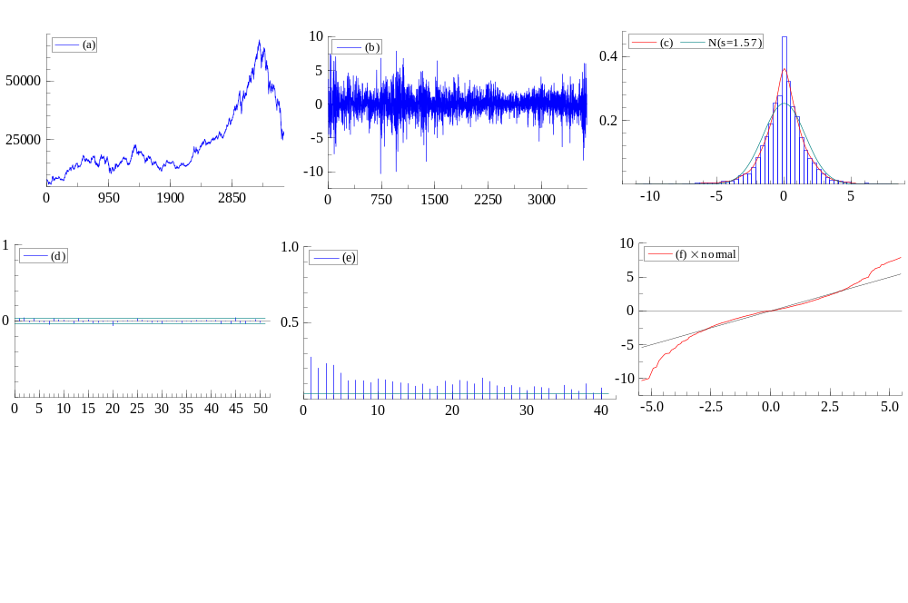
(a): Time plot of POLWIGI index.
(b): POLWIGI index returns.
(c): Histogram and estimated density plot of POLWIGI index. 5% significance level.
(d): Correlogram (or autocorrelation function, ACF) of POLWIGI index returns. 5% significance level.
(e): Correlogram (autocorrelation function, ACF) of POLWIGI index squared returns. 5% significance level.
(f) QQ plot for POLWIGI index returns.

Table 2. The stimated results of the TA-ARSV and ARSV models

 | TA-ARSV |  |  |  | ARSV
 | Stimated parameters |  |  |  | Stimated Parameters |  |  | LR¹
Series | σ* | φ₁₁ | φ₁₂ |  | σ* | φ |  | λ
EURO STOXX 50 | 0.187  (0.063) | 0.960  (0.285) | 0.999  (0.640) | 0.712 | 0.032  (0.064) | 0.983  (0.179) | 0.926 | 42.46
POLWG20 | O.196  (0.079) | 0.970  (0.299) | 0.974  (0.268) | 2.885 | 0.030  (0.244) | 0.971  (0.572) | 2.735 | 1.48
POLWG40 | 0.228  (0.104) | 0.951  (0.470) | 0.993  (0.969) | 0.851 | 0.045  (0.138) | 0.975  (0.389) | 0.922 | 13.02
POLWIGI | 0.186  (0.086) | 0.958  (0.297) | 0.989  (0.310) | 1.690 | 0.033  (0.098) | 0.973  (0.205) | 1.752 | 14.88
POLWIRR | 0.254  (0.080) | 0.952  (0.334) | 0.985  (0.309) | 1.612 | 0.060  (0.070) | 0.970  (0.144) | 1.597 | 7.58
¹Likelihood Ratio Contrast (LR). Critical value: 3.84 (5%).
The value between parenthesis for σ*, φ₁₁, φ₁₂ and φ is the standard error.

Figure 2. POLWIGI index returns and differences between the volatility estimated
(TA-ARSV(1))-(ARSV(1)). Sample period from 2/1/1995 to 12/15/2008.
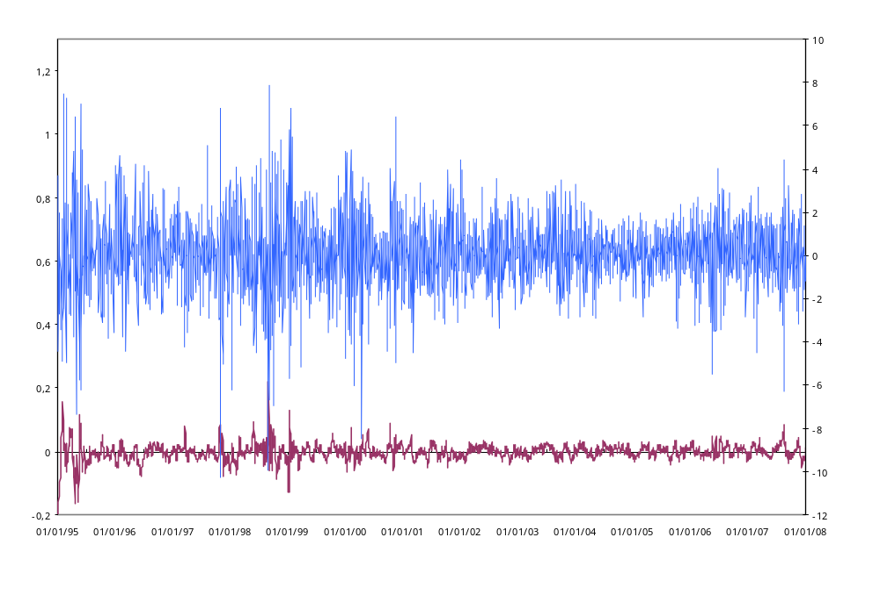
POLWIGI index returns
Differences of valilities
REFERENCES.

Asai, M. (2008). “Autoregressive stochastic volatility models with heavy-tailed distributions: A comparison with multifactor voaltility models”. Journal of Empirical Finance, 15, pp. 332-341.
Carnero, M.A., Peña, D. and Ruiz, E. (2004). “Persistente and kurtosis in GARCH and stochastic volatility models”. Journal of Financial Econometrics, 2, pp. 319-342.
Doornik, J.A (2001). “An object-oriented matrix programming language using Ox”. Timberlake Consultants Ltd., http://timberlake.co.uk.
Engle, R.F (1982). “Autoregressive conditional heteroskedasticity with estimates of the variance of United Kingdon inflation”. Econometrica, 50, pp. 987-1007.
García, M.C. (2008). “Modelo de volatilidad estocástica asimétrica por umbrales (modelo TA-ARSV)”. Rect@, 9, pp. 45-86.
Harvey, A. C.; Shephard, N. G. (1996) “Estimation of an asymmetric stochastic volatility model for asset returns”. Journal of Business and Economic Statistics, 14, pp. 429-434.
Koopman, S. J.; Shephard, N. and Doornik, J. A. (1999). “Statistical algorithms for models in state space using SsfPack 2.2”, Econometrics Journal, 2, pp.1-55.
Sandmann G.and Koopman, S. J (1998). “Estimation of stochastic volatility models via Monte Carlo maximum likelihood”. Journal of Econometrics, 87 pp. 271-301.
Taylor, S.J. (1982). “Financial returns modeled by the product of two stochastic processes-a study of daily sugar prices 1961-79”. In: Anderson, O.D. (Ed.), Time series analysis: Theory and Practice, vol.1. North-Holland, Amsterdam, pp.203-226.
Taylor, S.J.(1986) Modelling Financial Time Series. John Wiley, Chichester.
Tom, H. and Lim, K.S. (1980). “Threshold autoregressions, limits cycles and data”. Journal of the Royal Statistical Society, B42, pp.245-292.

It is possible to suggest another autoregressive stochastic volatility models with heavy-tailed distributions, such as a t-distribution, Asai (2008).
This especification is similar than the TAR model for the conditional mean proposed by Tong and Lim (1980).
The information of these indexes is obtained from the Datastream Data Base.
There are some financial time series which show a small correlation in mean, this dependence can be modelled with a low order autoregressive or moving average model with a little coefficient.
The estimation method was developed by Doornik (2001) in the Ox programming language and SsfPack 2.2 program, Koopman et al.,(1999) for the ARSV model.

