First principle investigation of structural properties of potassium doped fullerene clusters – K_{n}(C₆₀)₂.

M. Sokół*, Z. Gburski
Institute of Physics, University of Silesia, Uniwersytecka 4, 40-007, Katowice, Poland
*Corresponding author: msokol@us.edu.pl

Keywords: Potassium-fullerene nanosystem, first principle simulation, DFT calculation, alkali doped fullerene, K_{n}(C₆₀)₂ cluster

Abstract. We have performed a first principle simulations for the nanosystems K_{n}(C₆₀)₂, (n = 1, 2) composed of two fullerene (C₆₀) molecules and one or two potassium (K) atoms. The very effective delocalization of the 4s¹ valence electron of potassium was observed, the potassium atom in practice becomes an ion. The adsorption (biding) energy of potassium atom(s) is
E_{a} = - 1.923 ± 0.04 eV, - 3.819 ± 0.04 eV for K(C₆₀)₂ and K₂(C₆₀)₂, respectively. The reported large values of adsorption energy should cause a significant change in electronic properties of alkali doped fullerene clusters.

Introduction

In recent years, fullerenes have been intensively studied due to their unusual physical and chemical properties [1-3]. The discoveries of conducting and superconducting doped fullerides [3, 4] have initiated a strong interest in experimental studding fullerene covered with alkali metals, i.e. A_{n}C₆₀ systems (A - alkali metal atom) [5-10]. The relative high dielectric permitivity ε = 4.4 of solid C₆₀ [11] determines the significant difference between the binding energies of (C₆₀)₂ and (C₆₀)₂⁺[12], the relatively high binding energy of C₆₀⁺ in (C₆₀)_{n}⁺ clusters, and the large stabilization energies obtained for exohedral AC₆₀ complexes [13]. From these results one can expect large values for the binding energies of ions in fullerene clusters, such as A_{n}(C₆₀)₂.
Because of the difficulty of preparation and measurements of nanocomposities, the molecular dynamics simulations (classical or quantum called ab initio) can be exploit as a valuable tool for providing an atomistically detailed description of complex molecular processes occurring in these extremely small systems.
We used the density-functional theory (DFT) [14, 15] in its Generalized Gradient Approximation (GGA) [16-18] applying SIESTA programming code [19]. The core electrons were replaced by normconserving pseudopotentials in their fully separable form. The non-linear exchange-correlation correction [20-22] was included for potassium atom to improve the description of the core-valence interactions.

Results
It is known that the attractive part of fullerene-fullerene interaction potential is very strong, as a result of the high atomic density on the surface of the C₆₀ [23 - 26]. It was shown [3, 4] that addition of alkali atoms into fullerene based bulk samples significantly change their physical properties (conductivity, polarizability, …etc ). The studies of finite systems (clusters, ultrathin-films) composed of C₆₀ are not so yet advanced. However, in recent years an increasing activity in this field is observed, since the finite size extremely small fullerene based systems are expected to exhibit new physical and chemical properties. Following this path here we focus on the extremely small, potassium doped nanosystems K(C₆₀)₂ and K₂(C₆₀)₂.
We start by searching the equilibrium configuration of (C₆₀)₂ system. For that matter, first we find the equilibrium configuration of the pair of fullerenes only (without potassium atoms). Next in order to obtain the binding curve for K atom adsorbed by (C₆₀)₂ cluster, we calculate the adsorption energy varying the positions of potassium atom by 0.1 Å in Z axis, up to 8 Å (see Fig. 1). The adsorption energy E_{a} is defined as the total energy gained by (C₆₀)₂ system due to addition of the potassium, E_{a} = E_{t}[K_{x}(C₆₀)₂] – E_{t}[(C₆₀)₂] – x*E_{t}[K] (x = 1, 2). The binding curve for K atom adsorbed by (C₆₀)₂ cluster is shown in Fig. 2. For the potassium atom placed at the distance ~ 4.5 Å above the middle of the axis connecting the centers of mass of C₆₀ molecules (in the minimum of E_{a}), we obtained E_{a} = - 1.923 ± 0.04 eV, - 3.819 ± 0.04 eV for K(C₆₀)₂ and K₂(C₆₀)₂, respectively.
We have also calculated the charge density, for pure fullerene cluster (C₆₀)₂ and for both doped systems K_{n}(C₆₀)₂. One can see that in K(C₆₀)₂ as well as in K₂(C₆₀)₂, the addition of potassium atom modifies only very slightly charge density distribution of the pure fullerene cluster (Fig 3a, b). To better understand charge density modification we also plot the difference between pure fullerene cluster (C₆₀)₂ and the system doped by one or two potassium atoms (see Fig. 3c, d). Analyzing
Fig. 3c, d, one can see that the only one unbound (4s¹) electron from potassium atom, in both cases, is shared between two fullerene molecules. To obtain a quantitative information we additionally made the Mulliken population analysis which confirms an evenly dispersion of potassium 4s¹ valence electron over both fullerenes. Strictly speaking, we have found that only the charge q = - 0.131 e remains within potassium atom in K(C₆₀)₂ system. In case of K₂(C₆₀)₂ each potassium atom holds the charge q = - 0.136 e from 4s¹ valence electron. Therefore, losing one electron the potassium atoms in practice become the ions (K⁺).
The calculated density of states (DOS) diagrams is presented in Fig. 4. The potassium doping of pure fullerene cluster (C₆₀)₂ shifts its DOS towards lower energies, both for K(C₆₀)₂ and K₂(C₆₀)₂. Addition of K atom induces several discrete peaks on the main DOS distribution. The calculated DOS for the doped samples have similar shape and peak energies but different peak heights.

Summary
In conclusion, our calculations show that the single 4s¹ electron of potassium atom is very highly delocalized (only the charge q ∼ - 0.13 e remains within potassium atom) in K_{n}(C₆₀)₂ systems. Therefore, the potassium atom in practice becomes an ion. The adsorption energy of potassium atom(s) in both studied systems K(C₆₀)₂, K₂(C₆₀)₂ is quite large – the consequence of high ionization of alkali (K) atom. The adsorption of alkali metals should cause a significant change in electronic properties of fullerene cluster due to charge transfer and charge fluctuation.

Acknowledgments
This research was supported by a computer time grant No. G30-12 from the Interdisciplinary Center for Mathematical and Computational Modeling, Warsaw University.
References
[1] M. S. Dresselhaus, J. Dresselhaus, P. C. Eklund, Science of Fullerenes and Carbon Nanotubes Academic, New York (1995).
[2] H. Kuzmany, B. Burger, J. Kurti, Optical and Electronic Properties of Fullerenes and Fullerene-Based Materials, edited by J. Shinar, Z. V. Vardeny, Z. H. Kafaﬁ Dekker, New York (2000).
[3] R. C. Haddon et al., Nature (London) 350 (1991) p. 320
[4] D.W. Murphy et al., J. Phys. Chem. Solids 53 (1992) p. 1321
[5] S. Wehrli, E. Koch, M. Sigrist, Phys. Rev. B 68 (2003) p. 115412
[6] B. Verberck, V. N. Popov, A. V. Nikolaev, D. Lamoen, J. Chem. Phys. 121 (2004) p. 321
[7] A. V. Nikolaev, K. H. Michel, J. Chem. Phys. 122 (2005) p. 64310
[8] A.Dawid, Z. Gburski, Phys. Rev. A 56 (1997) p. 3294
[9] A.Dawid, Z. Gburski, J. Mol. Struct. 410 (1997) p. 507
[10] A.Dawid, Z. Gburski, J. Mol. Struct. 704 (2004) p. 287
[11] A. F. Hebard, R. C. Haddon, R. M. Fleming, A. R. Kortan, Appl. Phys. Lett. 59 (1991) p. 2109
[12] W. Branz, N. Malinowski, A. Enders, T. P. Martin, Phys. Rev. B 66 (2002) p. 094107
[13] A. Ruiz, J. Hernández-Rojas, J. Bretón, J. M. Gomez Llorente, J. Chem. Phys.
109 (1998) p. 3573
[14] R. Car, M. Parrinello, Phys. Rev. Lett. 55 (1985) p. 2471
[15] P. Hohenbergand, W. Kohn, Phys. Rev. 136 (1964) p. 864
[16] W. Kohn, L.J. Sham, Phys. Rev. A 140 (1965) p.1133
[17] A.D. Becke, Phys. Rev. A 38 (1988) p. 3098
[18] C. Lee, W. Yang. R.G. Parr, Phys. Rev. B 37 (1988) p. 785
[19] P. Ordejón, E. Artacho, J. M. Soler, Phys. Rev. B (Rapid Comm.) 53 (1996) R10441
[20] D. Sanchez-Portal, E. Artacho, P. Ordejon, J.M. Soler, Int. J. Quantum Chem.
65 (1997) p. 453
[21] L. Kleinman, D.M. Bylander, Phys. Rev. Lett. 48, (1982) p. 1425.
[22] S. G. Louie, S. Froyen, M.L. Cohen, Phys. Rev. B 26 (1982) p. 1738
[23] L. Liwei, D. Bedrov, G. D. Smith, Phys. Rev. E. 71 (2005) p. 011502
[24] A. Piątek, A. Dawid, Z. Gburski, J. Molec. Struc. 792 (2006), p.82
[25] A. Dawid, Z. Dendzik, Z. Gburski, J. Molec. Struc. 704 (1) (2004) p.173.
[26] A. Piątek, A. Dawid and Z. Gburski, J. Phys. Condens. Matter, 18 (2006), p.8471

Figures and caption

Fig. 1. Snapshot of the equilibrium configuration (minimum energy) of simulated K₂(C₆₀)₂ nanosystem. In case of K(C₆₀)₂ the top potassium atom is removed.

Fig. 2. The adsorption energy as a function of the distance (in Z axis direction, see Fig. 1) between potassium atom and the center of mass of both fullerene molecules.

Fig. 3. Contour plots of charge density of: a) K(C₆₀)₂ and b) K₂(C₆₀)₂ system. Plots c) and d) show the difference between pure fullerene cluster (C₆₀)₂ and fulleren molecules doped by one or two potassium atoms, respectively. The locations of potassium atoms are shown in Fig. 1.

Fig. 4. The density of states for: a) pure fulerene cluster (C₆₀)₂ and b), c) for fullerene cluster doped by one or two potassium atoms, respectively. Dotted lines denote the Fermi level.

Fig. 1 Sokół et al.
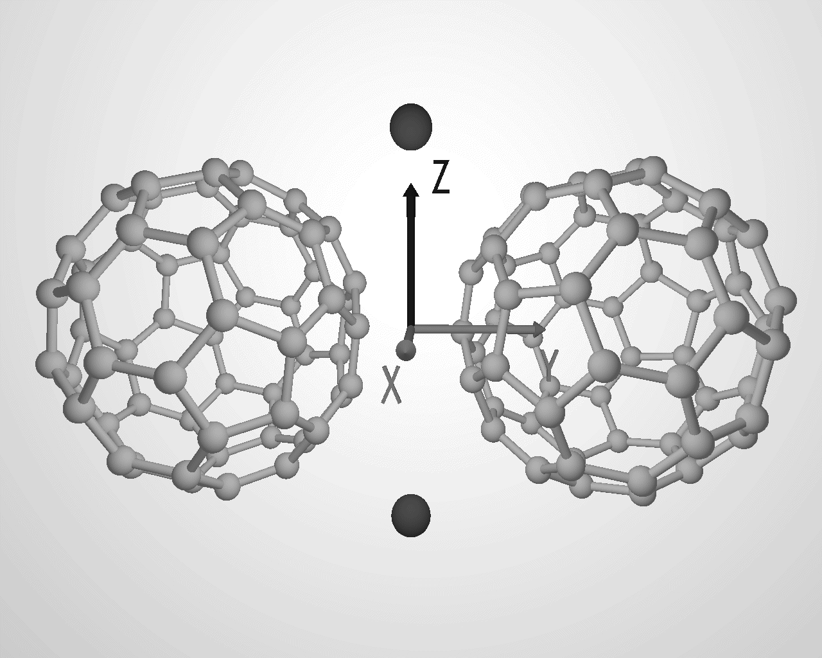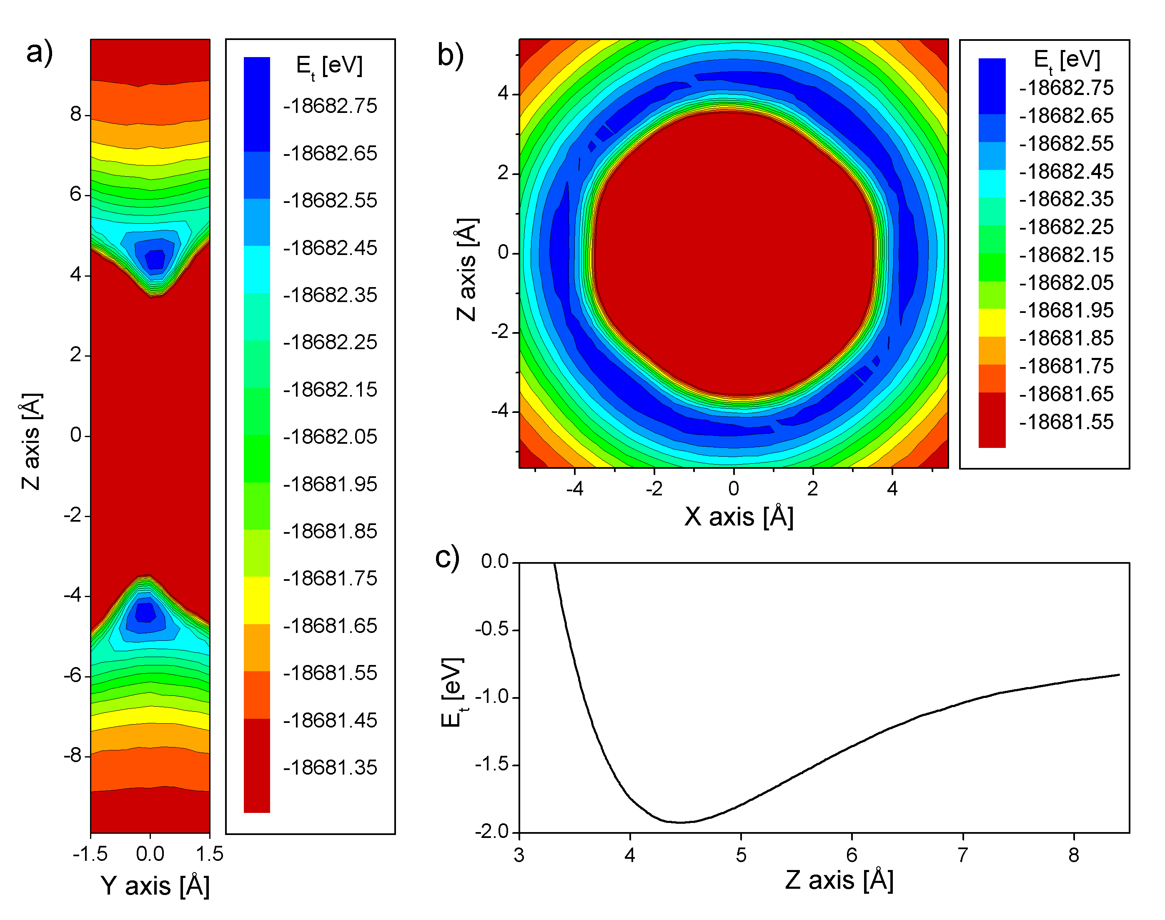
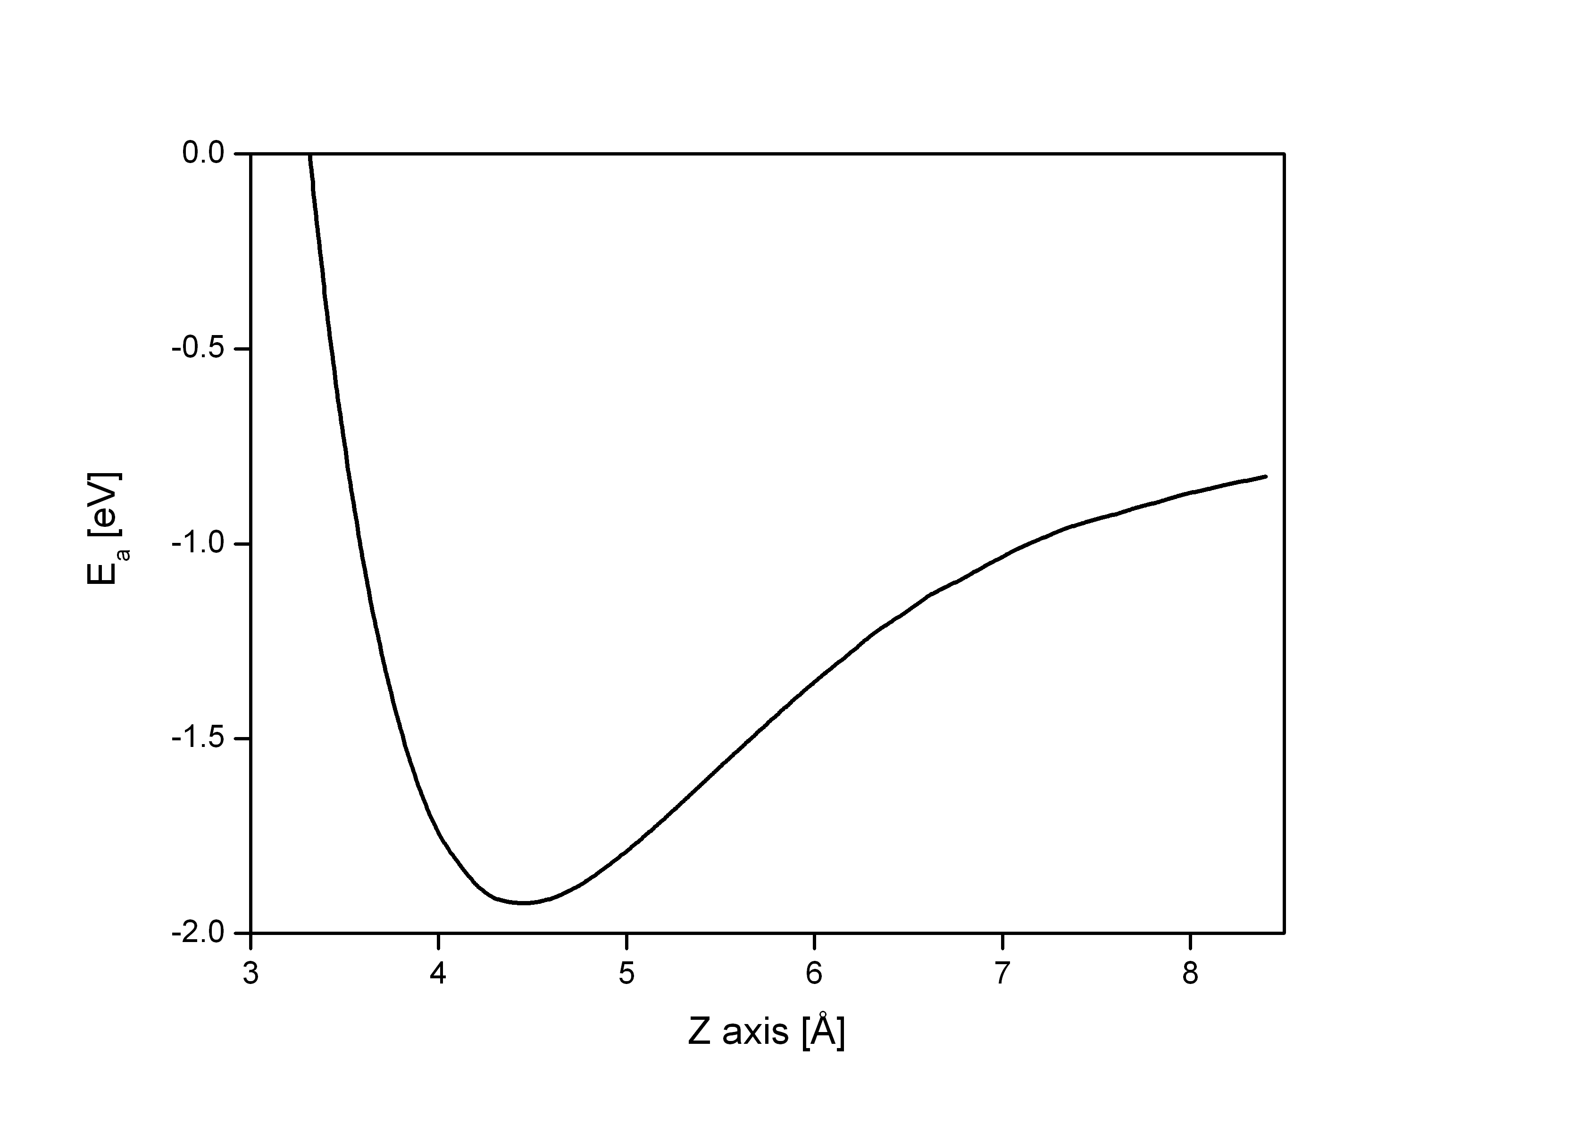
Fig. 2 Sokół et al.
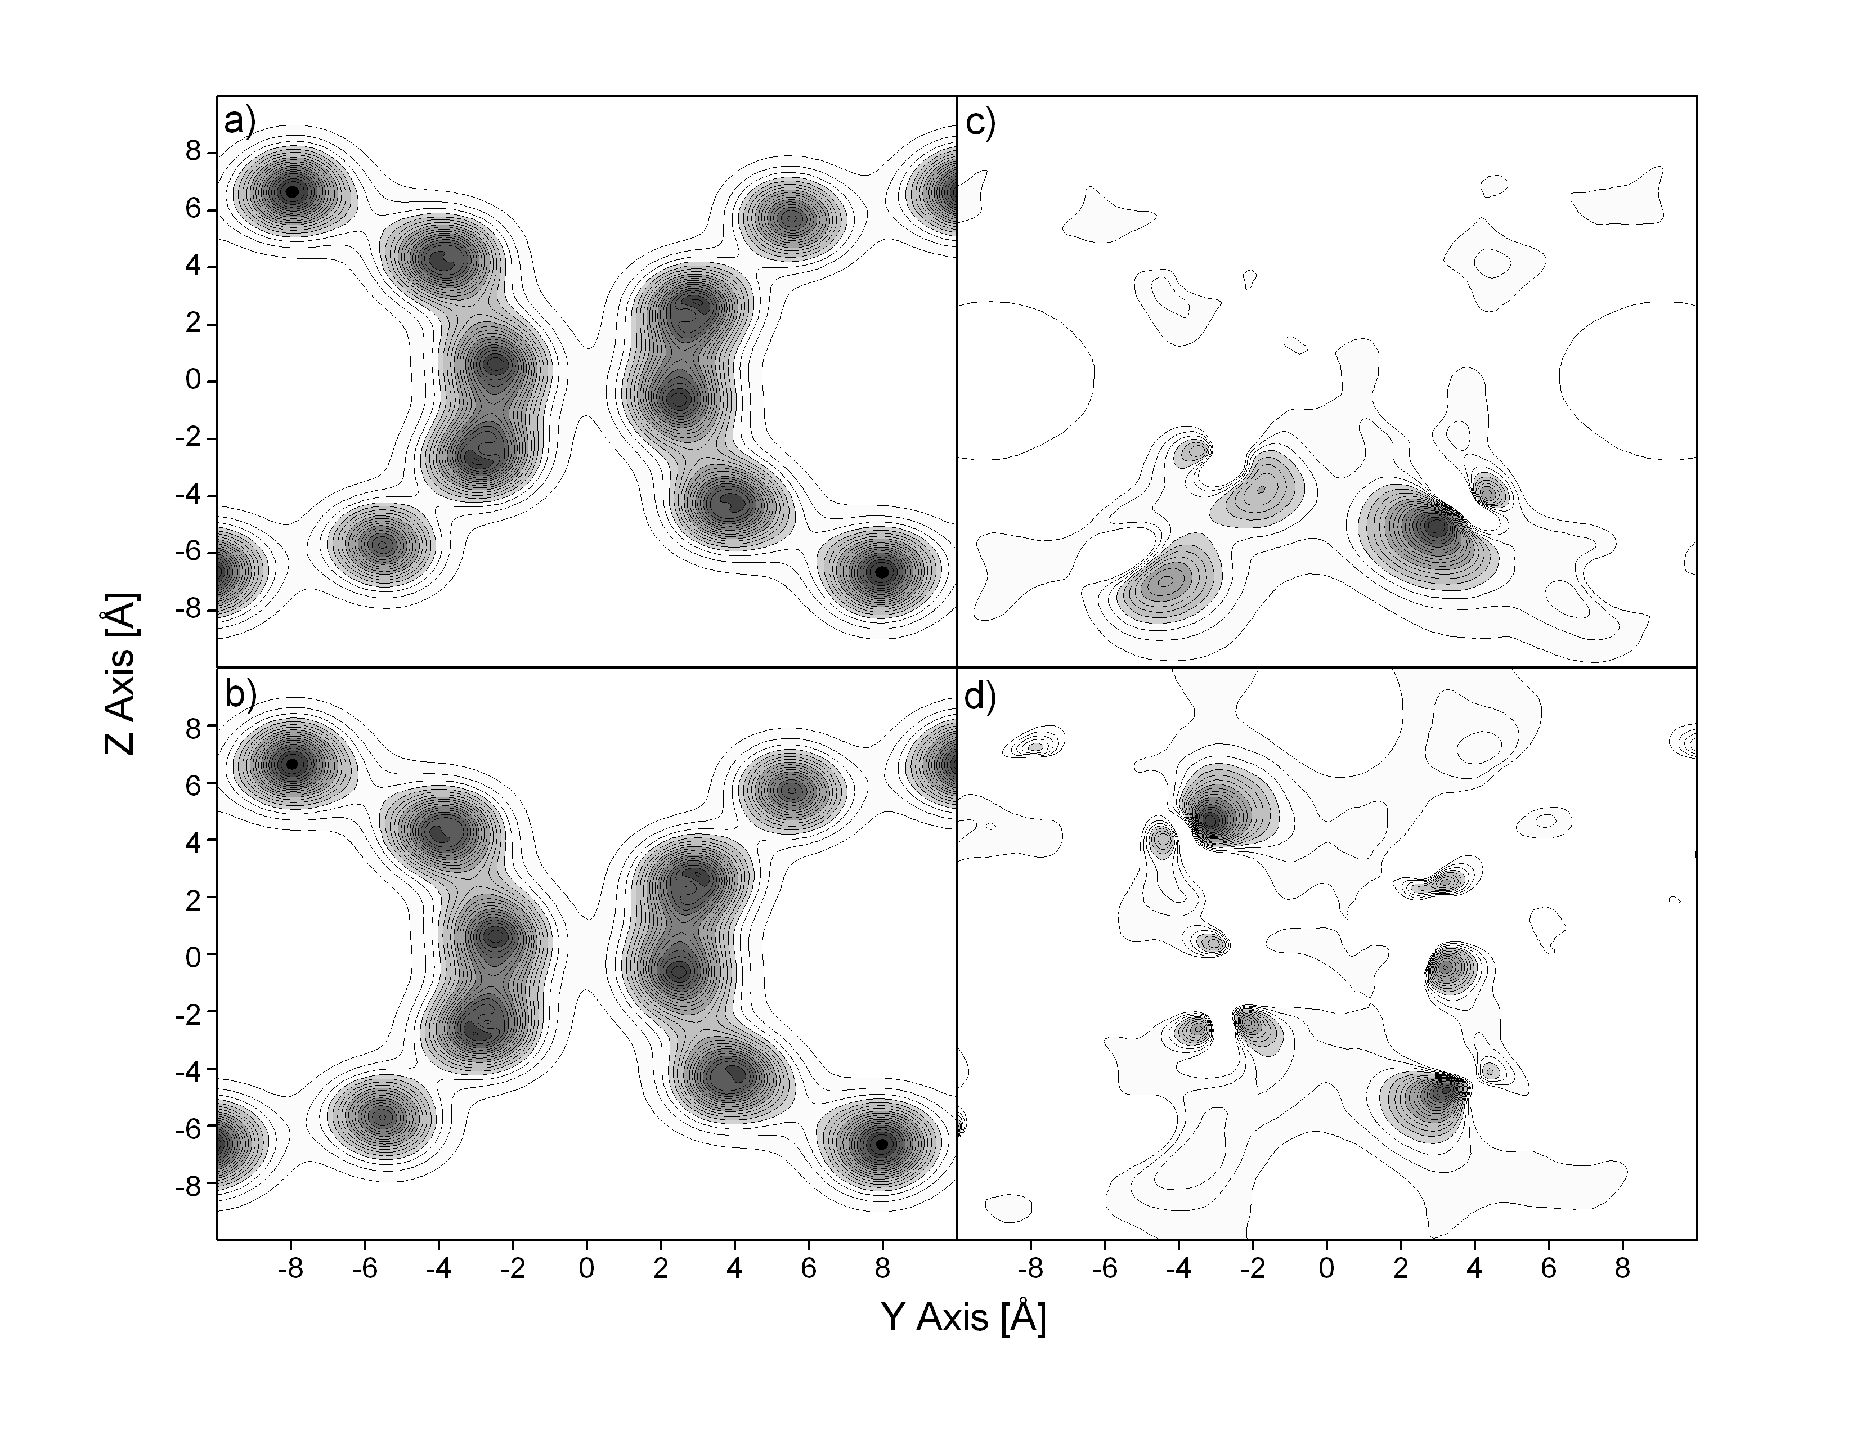
Fig. 3 Sokół et al.
Fig. 4 Sokół et al.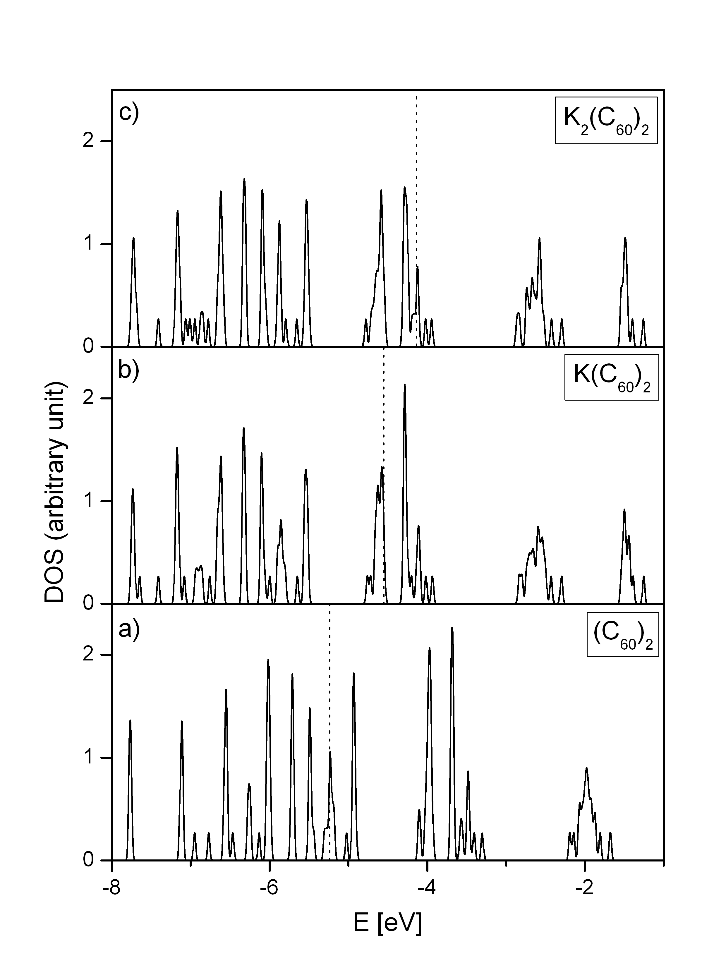
Fig. 4 Sokół et al.


